**A Report on**

**Plant Leaf Disease Detection System**

*Submitted for partial fulfilment of award of degree*

**BACHELOR OF TECHNOLOGY**

In

Computer Science & Engineering (Data Science)

By

SHIKHAR SHARMA – 2100301540071

PIYUSH PANDEY – 2100301540052

UJJWAL SINGH – 2100301540079

YASH SRIVASTAVA – 2100301540087

Name of the guide

MS. RATI GOYAL



**INDERPRASTHA ENGINEERING COLLEGE, GHAZIABAD,**

**Dr. A P J ABDUL KALAM TECHNICAL UNIVERSITY**

**LUCKNOW**

**May 2025**

**CERTIFICATE**

This is to certify that the Project Report entitled, "**Plant Leaf Disease Detection System**" and submitted by **Shikhar, Piyush, Ujjwal,** and **Yash** in partial fulfilment of the requirement for the award of Bachelor of Technology degree in **Computer Science and Engineering (Data Science)** at **Inderprastha Engineering College, Ghaziabad** is an authentic work carried out by him under my supervision and guidance. To the best of my knowledge, the matter embodied in the thesis has not been submitted to any other University/Institute for the award of any Degree or Diploma.

Ms. Rati Goyal Dr. Sudhir Dawra

Assistance Professor HOD CSE (Data Science)

Inderprastha Engineering College Inderprastha Engineering College

Ghaziabad Ghaziabad

i

Acknowledgement

We take this opportunity to thank our teachers and friends who helped us throughout the project. First and foremost, I would like to thank my guide for the project (Name of the Guide, designation, Department) for her/his valuable advice and time during development of project. We would also like to thank Dr. Sudhir Dawra (HOD, Computer Science and Engineering (Data Science)) for his constant support during the development of the project.

Shikhar Sharma Piyush Pandey

2100301540071 2100301540052

Signature: Signature:

Ujjwal Singh Yash Srivastava

2100301540079 2100305140087

Signature: Signature:

ii

Declaration

*I hereby declare that this submission is my own work and that, to the best of my knowledge and belief, it contains no material previously published or written by another person nor material which to a substantial extent has been accepted for the award of any other degree or diploma of the university or other institute of higher learning, except where due acknowledgment has been made in the text.*

Signature: Signature:

Shikhar Sharma Piyush Pandey

2100301540071 2100301540052

Signature: Signature:

Ujjwal Singh Yash Srivastava

2100301540079 2100305140087

iii

Abstract

*Agriculture is essential for many nations' incomes. Diseases in plants caused by pathogens such as viruses, fungi, and bacteria cause global financial losses in agriculture. Effective disease management ensures crop quality and yield. Disease symptoms are often visible on various plant parts, with leaves being the most affected. Researchers have utilized computer vision, deep learning, few-shot learning, and soft computing techniques to automatically identify plant diseases using leaf images. These technologies help farmers act promptly to protect crops. By automating disease detection, these methods resolve limitations of traditional methods, enhancing both research speed and technology effectiveness. Additionally, molecular techniques have been developed to mitigate pathogenic threats. This review examines the use of machine learning, deep learning, and few-shot learning for automated plant disease detection, reviews diagnostic techniques and future advancements. The integration of these advanced techniques into agricultural practices not only aids in timely disease detection but also sup ports sustainable farming by reducing reliance on chemical treatments. By lever aging machine learning and molecular diagnostics, farmers can implement targeted interventions, minimizing environmental impact and improving resource efficiency. These innovations are vital in addressing the growing challenges of food security and climate change, ensuring the resilience of agricultural systems worldwide. The CNN model that we built achieves an accuracy of 81.83 %.*

***Keywords:*** *Deep learning, diagnosis, image processing, machine learning, and plant disease.*

iv

**TABLE OF CONTENTS**

**CHAPTER NO. TITLE PAGE NO.**

**ABSTRACT ………………………………………… iv**

**LIST OF TABLES …………..……………………… ix**

**LIST OF FIGURES ………..……………….………. x**

**LIST OF SYMBOLS/ABBREVIATIONS ………… xi**

**1. INTRODUCTION…………………………………….. 1**

* 1. Project Definition ………………….……..…………… 2
  2. Background of Project …………….……….……....….. 3
  3. Project Objective ………………….……………..……. 3
  4. Feasibility Study ………………….……………..…….. 4

1.4.1 Technical Feasibility ………………….…..……. 4

1.4.2 Economic Feasibility ………………...…………. 4

1.4.3 Operational Feasibility ……….……...…………. 4

1.4.4 Legal & Ethical Feasibility ……………..………. 5

* 1. Phytopathology …………………….…………………… 5

1.5.1 Plant Disease Types & Symptoms ………………. 6

* 1. Importance of Leaf Disease Detection .………...….…… 8
  2. Techniques for Disease Detection …….…………...…… 8

1.7.1 Machine Learning Methods …………………….. 8

1.7.2 Deep Learning Techniques ……………………… 11

**2. LITERATURE REVIEW……………………………. 12**

**3. SOFTWARE REQUIREMENT ANALYSIS ……….. 18**

3.1 Functional Requirement …...………………….……..… 18

3.1.1 Image Upload and Input ………………………... 18

3.1.2 Image Processing and Disease Detection ………. 18

3.2 Systems Requirement……………………….………….. 18

3.2.1 AI Model and Libraries ………………………… 18

3.3 Cloud Service Requirement……………...…….……….. 21

3.3.1 Amazon Web Services ………………………….. 21

3.3.2 Microsoft Azure ………………………………… 22

3.3.3 Google Cloud Platform …………………………. 22

3.4 Testing Frameworks …………………………....………. 23

3.4.1 Confusion matrix ……………………………….. 23

3.4.2 Accuracy metrics ……………………………….. 24

3.4.3 Robustness tests ………………………………… 25

3.5 Other Requirement………………………………..……. 26

3.5.1 Integration Requirements ………………………. 26

3.5.2 Hardware Requirements ……………………...… 26

**4. SYSTEM ANALYSIS & DESIGN ………………….. 27**

4.1 Class Designs ……………………………………...….. 27

4.2 Sequence Diagrams ……………………………..……. 28

4.3 Activity Diagrams ……………………………...…….. 28

4.4 DFDs of the project …………………………...……… 29

4.5 Database Design ………………………………...……. 30

4.5.1 E-R Diagrams …………………………………. 30

**5. IMAGE PROCESSING …………………………….. 32**

5.1 Introduction ……………………………...……..….….. 33

5.1.1 Objective of Image Processing …………..……. 33

5.1.2 Image Types …………………………………… 33

5.1.3 Types of Image Processing ……………………. 34

5.2 Image Processing Methodology ………………….…… 35

5.2.1 Data Preprocessing …………………………….. 36

5.2.2 Image Segmentation ………………………..….. 36

5.2.3 Feature Extraction ………………………….….. 36

5.2.4 Model Training ……………………………..….. 36

5.2.5 Model Evaluation ……………………………… 37

5.2.6 Deployment on Local Web Application ……….. 38

5.3 Introduction to Machine Learning ………………….… 38

5.3.1 Algorithms Used ………………………………. 39

5.4 Technology Used …………………………………...… 40

5.4.1 Python ……………………………………….… 41

5.4.2 Python Libraries ….………………………….… 41

5.4.3 Pandas ……………………………………….… 41

5.4.4 Scikit-learn ………………………………….… 42

5.4.5 NumPy ……………………………...……….… 42

**6. METHODOLOGY …………………………..………. 43**

6.1 Introduction ………………………………...…….…… 43

6.1.1 Convolutional Neural Networks (CNN) ………. 43

6.1.2 Transfer Learning ……………………………… 44

6.1.3 ResNet50 ………………………………………. 44

6.2 The Dataset ………...……………………………….…. 47

6.2.1 Training Dataset ……………………………….. 47

6.2.2 Testing Dataset ………………………………… 48

6.2.3 Importance of Splitting the Dataset …………… 48

6.2.4 Difference Between Training & Testing Data …. 48

6.3 Image Preprocessing ……………..………...………..… 48

6.3.1 Importance of Image Pre-Processing …………... 48

6.3.2 Criteria for Image Pre-Processing ………………. 49

6.3.3 Common Image Pre-Processing Techniques ……. 49

6.3.4 Loading a Custom Dataset for DL Models ……… 50

6.4 Data Augmentation ………………………...…………… 50

6.4.1 Steps in Image Data Augmentation ……………... 50

6.4.2 Image Augmentation Using Keras ……………… 51

6.5 Feature Extraction (ResNet50) …..……………...……… 52

6.5.1 Importance of Feature Extraction ……………….. 52

6.5.2 Constructing the ResNet50 Model ……………… 53

6.6 Model Training ……..…………………………...……… 53

**7. RESULTS ……………………………………………… 55**

7.1 Result of Leaf Images ……………………………..…… 55

7.2 Experiment ….…………...………………...…………… 56

7.3 The Webpage ………...…………..………...………........ 58

**CONCLUSIONS / RECOMMENDATIOS ………………………………... 61**

**REFERENCES ……………………………………………………………… 63**

**PLAGIARISM REPORT …………………………………………………... 69**

**RESEARCH PAPER PUBLICATION (PUBLISHED PAPER/PAPER STATUS WITH JOURNAL /CONFERENCE NAME) …………………………….. 70**

**APPENDICES**

**LIST OF TABLES**

Table 2.1 Literature Review

Table 2.2 Distinct disease in different plants

Table 2.3 Distinct plants, their disease and responsible pathogen

Table 2.4 Details of techniques used by various researchers

Table 2.5 Details of data augmentation technique is used by various researchers

Table 7.1 Classification Report

ix

**LIST OF FIGURES**

Fig 1.1 Apple leaf infected with rust

Fig 1.2 Farmer’s Usage

Fig 1.3 Phytopathology Objectives

Fig 1.4 Subdomains of phytopathology

Fig 1.5 Bacterial Diseases

Fig 1.6 Viral Diseases

Fig 1.7 Fungal Diseases

Fig 1.8 CNN Image Processing Architecture

Fig 2.1 Classification Techniques by Various Researchers

Fig 2.2 Data Augmentation Technique by Various Researchers

Fig 4.1 Class Diagram

Fig 4.2 Sequence Diagram

Fig 4.3 DFD Level – 0

Fig 4.4 DFD Level – 1

Fig 4.5 Activity Diagram

Fig 5.1 Binary Image

Fig 5.2 Gray scale Image

Fig 5.3 Flowchart (Methodology)

Fig 5.4 Working of Random Forest Algorithm

Fig 6.1 Residual Block

Fig 6.2 Block Diagram of ResNet50

Fig 6.3 Convolutional Block

x

Fig 6.4 Identity Block

Fig 6.5 ResNet50 Architecture

Fig 6.6 Training Model

Fig 6.7 Evaluating Model

Fig 7.1 Healthy Leaf

Fig 7.2 Diseased Leaf – Low

Fig 7.3 Diseased Leaf – Medium

Fig 7.4 Diseased Leaf – High

Fig 7.5 Visualization of classification

Fig 7.6 Webpage

Fig 7.7 Choosing the image file

Fig 7.8 Click Predict Button

Fig 7.9 Output with leaf and its disease

xi

**LIST OF SYMBOLS/ABBREVIATIONS**

xii

|  |  |
| --- | --- |
| **Abbreviation** | **Full form** |
| KNN | K-Nearest Neighbour |
| SVM | Support Vector Machine |
| CNN | Convolutional Neural Network |
| GPDCNN | Global pooling dilated CNN |
| MCNN | Multilayer convolutional neural network |
| PSO | Particle Swarm Optimization |
| DCNN | Deep Convolution Neural Network |
| CCM | Color Co-occurrence Matrix |
| GLCM | Gray Level Co-occurrence Matrix |
| MER | Minimum Enclosing Rectangle |
| DWT | Discrete Wavelet Transform |
| SIFT | Scale Invariant Feature Transform |
| HOG | Histogram of Oriented Gradients |
| STL-10 | Self-Taught Learning 10 |
| ResNet | Residual Network |
| HSV | Hue Saturation Value |
| RGB | Red, Green, Blue |
| HDF | Hierarchical Data Format |
| AI | Artificial intelligence |
| MDP | Markov decision process |
| ML | Machine Learning |
| HTTP | HyperText Transfer Protocol |
| WSGI | Web Server Gateway Interface |
| PEP | Python Enhancement Proposal |
| BSD | Berkeley Source Distribution |
| AQR | Applied Quantitative Research |
| DBSCAN | Density-based spatial clustering of applications with noise |
| API | Application programming interface |
| RF | Random Forest |
| LR | Logistic Regression |
| VGG | Visual Geometry Group |
| JPEG | Joint Photographic Experts Group |
| BMP | Bitmap |

xiii

CHAPTER 1

INTRODUCTION

The United Nations' Food and Agriculture Organization has reported a consistent increase in global hunger since 2015. Current estimates suggest that approximately 680 million people are undernourished, accounting for less than 9% of the global population. This represents an annual increase of 10 million people and a rise of around 120 million over the last decade. Moreover, over 85% of the global population depends on agriculture for sustenance, underscoring the critical need for efficient farming mechanisms. Plants also play a vital role in maintaining environmental balance by producing oxygen through photosynthesis. However, plant diseases, particularly those affecting leaves, can severely impact plant health and disrupt food production. A historical ex ample is the 1845 Irish Potato Famine, which caused 1.2 million deaths due to crop failure [1]. Laboratory techniques such as immunosorbent enzyme assays, isothermal amplification, and polymerase chain reaction (PCR) are commonly employed to detect plant diseases. Early detection, effective management, and prevention of plant diseases are essential. However, diagnosing diseases in large agricultural fields is challenging, requiring skilled personnel and visual inspection of plant leaves [2]. Farmers typically rely on their experience to identify symptoms, a process that is time-intensive, laborious, and demands specialized skills. Automated disease detection systems aim to assist non-experts, including non-pathologists and non-botanists. This review explores auto mated techniques utilizing image processing, machine learning, deep learning, and few shot learning for plant disease detection. Traditional machine learning approaches often lack robustness and are confined to controlled laboratory settings [3]. In contrast, deep learning has recently demonstrated remarkable success in classifying plant disease images. However, deep learning methods require extensive datasets, with images meticulously annotated by pathologists and botanists. These processes are resource-intensive and costly.

Few-shot learning (FSL) offers an alternative by enabling models to learn from limited labeled datasets [4], where the number of samples depends on the experiment's objectives and complexity.

1

Various pathogens contribute to plant diseases and can be identified using molecular techniques such as DNA analysis, PCR, MPG (Modified Panchayat Mixture), ELISA (Enzyme-Linked

Immunosorbent Assay), FISH (Fluorescence in Situ Hybridization), and IF (Immunofluorescence) methods. This review paper provides a comparative analysis of machine learning, deep learning, and few-shot learning in plant disease detection. It also examines segmentation, feature extraction, and classification techniques alongside molecular diagnostic tools [5]. A typical symptom can be seen in (Fig. 1), which depicts an infected leaf.

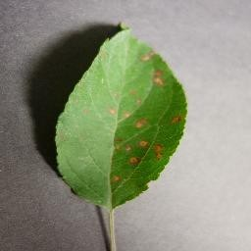

Fig. 1.1 Apple leaf infected with rust

1.1 Project Definition

The Plant Leaf Disease Detection project aims to develop an intelligent system that automatically identifies and classifies diseases present on plant leaves using artificial intelligence (AI) and computer vision techniques. The system will process images of plant leaves to detect visual symptoms of various diseases and accurately classify them into predefined categories. This project leverages deep learning models, particularly convolutional neural networks (CNNs), and may include alternative machine learning methods like SVM or XGBoost for comparative evaluation. The goal is to assist farmers and agricultural professionals in early disease detection, reduce crop loss, and support timely and effective disease management.

2

1.2 Background about the project idea

Agriculture plays a vital role in the global economy, particularly in countries where a significant portion of the population relies on farming for their livelihood. However, one of the major challenges faced by farmers is the early detection and effective management of plant diseases, which can severely impact crop yield and quality. Traditionally, identifying plant diseases requires expert knowledge, regular monitoring, and manual inspection, which may not be practical or accessible for all farmers, especially in remote or rural areas. With recent advancements in artificial intelligence (AI) and computer vision, it is now possible to automate the process of plant disease detection using image-based analysis. By training machine learning models—especially convolutional neural networks (CNNs)—on large datasets of plant leaf images, systems can learn to recognize disease patterns and classify them with high accuracy. This project aims to develop a robust and intelligent solution for detecting and classifying plant leaf diseases. The system uses images of affected leaves as input and predicts the type of disease present, if any. Such a tool can empower farmers with quick and accurate information, enabling timely intervention and minimizing crop damage. The implementation of this technology has the potential to improve agricultural productivity and contribute to sustainable farming practices.

1.3 Project Objective

The objective of the project "Plant Leaf Disease Detection and Classification Using AI and Computer Vision Techniques" is to develop an intelligent system capable of identifying and classifying plant leaf diseases accurately and efficiently. By leveraging advanced AI algorithms and computer vision, the system aims to assist farmers and agricultural professionals in detecting diseases at an early stage, reducing crop losses, and improving productivity.



Fig 1.2 Farmer’s Usage

3

1.4 Feasibility

1.4.1 Technical Feasibility

Availability of Technology: The project leverages readily available technologies, such as deep learning frameworks (e.g., TensorFlow, PyTorch), computer vision libraries (e.g., OpenCV), and cloud computing platforms for scalable deployment.

Data Requirements: Datasets of diseased and healthy plant leaves are widely available in agricultural research repositories. Additionally, smartphone cameras and digital imaging devices make it easy to collect further data.

Conclusion: Technically feasible with current tools, resources, and expertise.

1.4.2 Economic Feasibility

Development Costs: Initial costs include data acquisition, model training, and system development. These can be minimized using open-source tools and publicly available datasets.

Operational Costs: Cloud deployment and model updates will incur recurring expenses, but these are scalable based on user demand.

Conclusion: Economically feasible with potential for substantial ROI (Return of Investment).

1.4.3 Operational Feasibility

User Accessibility: The system can be deployed as a mobile application or web-based platform, making it easily accessible to farmers, agronomists, and agricultural stakeholders.

Ease of Use: Intuitive interfaces with image upload options and simple outputs (e.g. disease name, severity, and recommendations) will ensure widespread adoption.

Conclusion: Operationally feasible with user-friendly design and scalable deployment.

4

1.4.4 Legal and Ethical Feasibility

Data Privacy: Ensuring the anonymity and security of images uploaded by users will be crucial. Standard data protection measures will address privacy concerns.

Regulatory Compliance: The system must comply with regional agricultural policies and technology regulations, especially if pesticides or treatments are recommended.

Bias and Fairness: Ensuring the AI model is trained on diverse datasets to avoid bias is essential to ensure fair and accurate predictions.

Conclusion: Feasible with adherence to ethical AI practices and data protection laws.

**Overall Feasibility: The project is technically, economically, operationally, and legally feasible. Its implementation can have a transformative impact on agriculture, offering a cost-effective, scalable, and accessible solution for plant disease management.**

1.5 Phytopathology

Phytopathology refers to the study of plant pathogens, the diseases they cause, their mechanisms, and methods to control and mitigate their impact on plants. It serves as a comprehensive framework for understanding and managing a plant's life cycle. Derived from Greek, "Phytopathology" combines "Phyto" (plant), "Patho" (disease), and "Logo" (knowledge) [6]. Its core objectives include investigating the origins and causes of plant diseases, whether biotic or abiotic (etiology), understanding the mechanisms behind disease development (pathogenesis), examining interactions between plant pathogens and diseases (epidemiology), and developing strategies to reduce damage and manage losses, as depicted in Fig. 1.3.

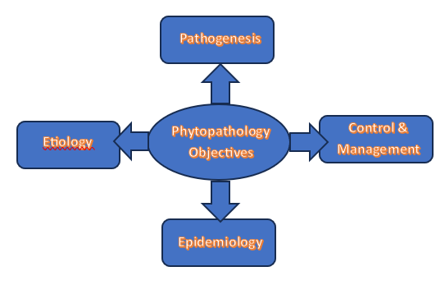

Fig. 1.3 Phytopathology Objectives

5

Phytopathology is a specialized subfield within agricultural science that integrates foundational knowledge from diverse disciplines such as microbiology, physiology, nematology, virology, anatomy, bacteriology, mycology, genetic engineering, botany, meteorology, climatology, and molecular biology, as illustrated in Fig. 1.4.

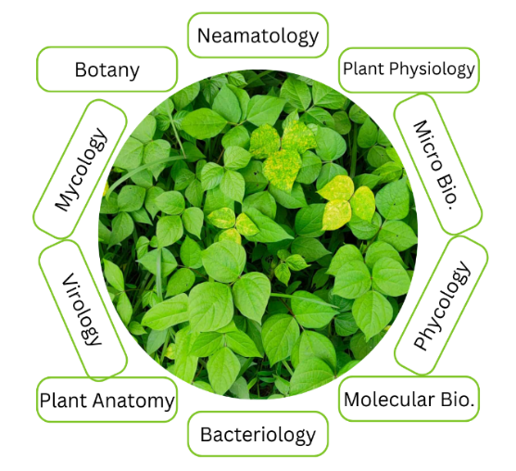

Fig. 1.4 Subdomains of phytopathology

1.5.1 Plant disease types & symptoms.

Bacterial Diseases. Bacterial infections in plants typically begin as water-soaked lesions that develop into small green blemishes. Over time, these lesions expand and dry into dead spots, as illustrated in Fig. 6. For instance, foliage may display water-soaked black blemishes, brown leaf spots, or yellow halos of uniform size. Under dry conditions, the blemishes often appear dappled. Bacterial wilt, a common issue in brinjal crops, causes the entire plant to collapse [7, 21].

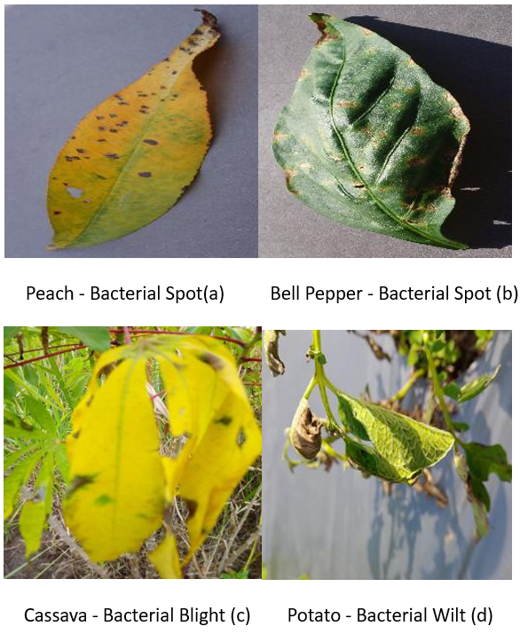

Fig. 1.5 Bacterial Diseases

6

Viral Diseases. Viral infections in plants are among the most challenging to diagnose, as they may exhibit no visible symptoms or mimic signs of herbicide damage or nutrient deficiencies [7].

Commonly observed viral disease include those transmitted by beetles, leafhoppers, aphids, and whiteflies, such as mosaic viruses, which manifest as green or yellow streaks on foliage, as shown in Fig. 1.6.

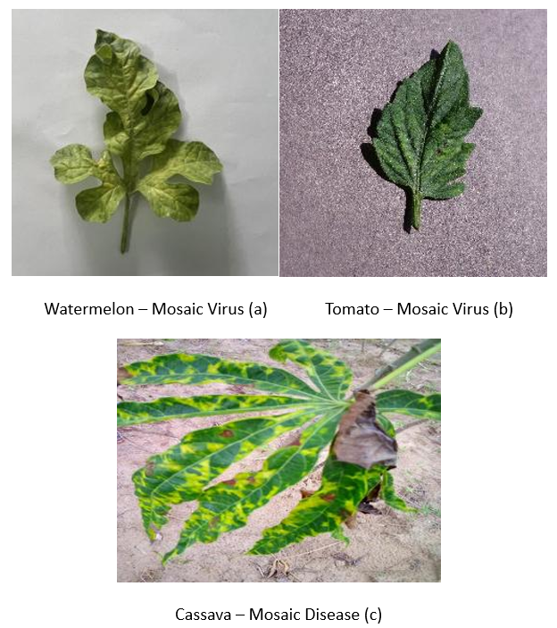

Fig. 1.6 Viral Diseases

Fungal Diseases. Fungal infections affect various parts of plants, including stems, leaves, seeds, and roots. Examples include sclerotium wilt, stem rust, blight, ergot, and carnal bunt. Late blight caused by Phytophthora fungus initially appears as gray green waterlogged blemishes on older leaves, as shown in Fig. 8 (a). Over time, these lesions darken, and white fungal growth may appear due to fluctuating wet and dry conditions [8]. Early blight caused by Alternaria fungus produces small brown blemishes with a characteristic concentric ring pattern, as shown in Fig. 8 (b). Rust fungi form spots on mature leaves that turn black over time, as illustrated in Fig. 1.7.

7

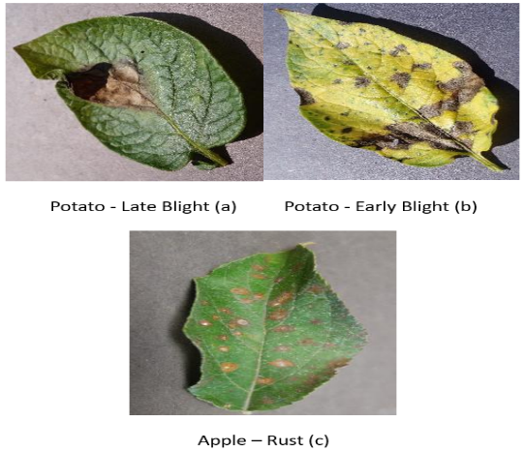

Fig. 1.7 Fungal Diseases

1.6 Importance of Plant Disease Detection

Accurate identification of plant diseases is essential for effective disease control. Without it, control measures may be misdirected, leading to wasted time, effort, and resources. In some cases, applying incorrect treatments can worsen the problem and cause further crop loss. Plant diseases are primarily caused by infectious agents such as fungi, bacteria, viruses, nematodes, and oomycetes. Since different pathogens can produce similar symptoms, precise diagnosis is critical for developing an effective management strategy. Additionally, it is important to distinguish between plant injuries and diseases—while injuries are typically caused by sudden external forces over a short period, diseases are the result of ongoing infections or infestations.

1.7 Techniques for disease detection

1.7.1 Machine Learning Methods

1.7.1.1 KNN

K-Nearest Neighbors (K-NN) is one of the simplest and most intuitive supervised machine learning algorithms. It assumes that similar data points exist close to each other in feature space. When presented with a new data point, the K-NN algorithm compares it to existing instances and assigns it the most common class among its 'K' nearest neighbors.

8

K-NN is a **lazy learner** algorithm, meaning it does not learn from the training data immediately. Instead, it stores the data and only performs computation when it is asked to classify a new instance. This makes K-NN a **non-parametric** method, as it does not make assumptions about the underlying data distribution.

Though K-NN can be used for both classification and regression problems, it is more commonly applied to classification tasks.

**Example:** During training, K-NN simply stores the dataset. When a new input is provided, the algorithm finds the 'K' closest points in the dataset and assigns the class that is most common among them.

1.7.1.2 Support Vector Machine

Support Vector Machine (SVM) is a powerful supervised learning algorithm primarily used for classification tasks, although it can also be used for regression. SVM's goal is to find the optimal hyperplane that best separates data points of different classes in an n-dimensional space.

The algorithm identifies the support vectors, which are the data points closest to the hyperplane and most influential in defining its position. These support vectors play a crucial role in the creation of the decision boundary.

Types of SVM:

* Linear SVM: Used when the data is linearly separable and can be divided using a single straight line (or hyperplane).
* Non-linear SVM: Used for datasets that are not linearly separable. In such cases, SVM applies kernel functions to transform the data into a higher dimension where it becomes linearly separable.

Key Concepts:

* Hyperplane: A decision boundary that separates different classes. The dimensionality of the hyperplane depends on the number of features. For example, with two features, the hyperplane is a straight line; with three, it becomes a plane.
* Support Vectors: The critical data points that are closest to the hyperplane and influence its orientation. They are the "support" of the SVM model.

9

1.7.1.3 Random Forest

Random Forest is a versatile and widely used supervised machine learning algorithm that can handle both classification and regression tasks. It is based on the concept of ensemble learning, which combines the predictions of multiple models to improve performance.

The Random Forest algorithm constructs multiple decision trees using different subsets of the training data and features.

The final prediction is made based on the majority voting (for classification) or averaging (for regression) of individual trees’ outputs. This reduces the risk of overfitting compared to a single decision tree and improves accuracy and robustness.

Advantages:

* Handles large datasets with higher dimensionality
* Reduces overfitting
* Improves prediction accuracy

1.7.1.4 Logistic Regression

Logistic Regression is a popular supervised learning algorithm used primarily for binary and multiclass classification problems. It predicts the probability of a categorical dependent variable based on one or more independent variables.

Unlike linear regression, which provides continuous output, logistic regression uses the logistic (sigmoid) function to map predictions to probabilities between 0 and 1.

Key Characteristics:

* Predicts categorical outcomes such as Yes/No, True/False, or 0/1.
* Outputs probabilities rather than exact values.
* Often used in medical, financial, and social science applications.

Sigmoid Function (Logistic Function):

* Converts real-valued input into a probability score between 0 and 1.
* Produces an “S”-shaped curve.

10

* Ensures that predictions stay within logical bounds.
* A threshold (e.g., 0.5) is used to classify the output into one of two categories.

Assumptions in Logistic Regression:

* The dependent variable must be categorical.
* Independent variables should not exhibit multicollinearity.

Types of Logistic Regression:

1. Binomial Logistic Regression: The dependent variable has two categories (e.g., Pass/Fail, Yes/No).
2. Multinomial Logistic Regression: The dependent variable has three or more unordered categories (e.g., Cat, Dog, Sheep).
3. Ordinal Logistic Regression: The dependent variable has three or more ordered categories (e.g., Low, Medium, High).

1.7.2 Deep Learning Techniques

1.7.2.1 The CNN (Convolutional Neural Network) Technique:

CNNs are deep feed-forward neural networks designed to analyze multidimensional data. They learn feature representations by activating specific channels when detecting key spatial patterns in the input data [15, 17, 18]. The accuracy of CNN models depends on factors such as the number of training epochs and the implementation of convolution filters, typically with dimensions of 2 × 2 or 3 × 3. Several pre-trained architectures enhance CNN performance, including VGG16, VGG19, ResNet50, ResNet152, InceptionV3, InceptionNet, and DenseNet121.

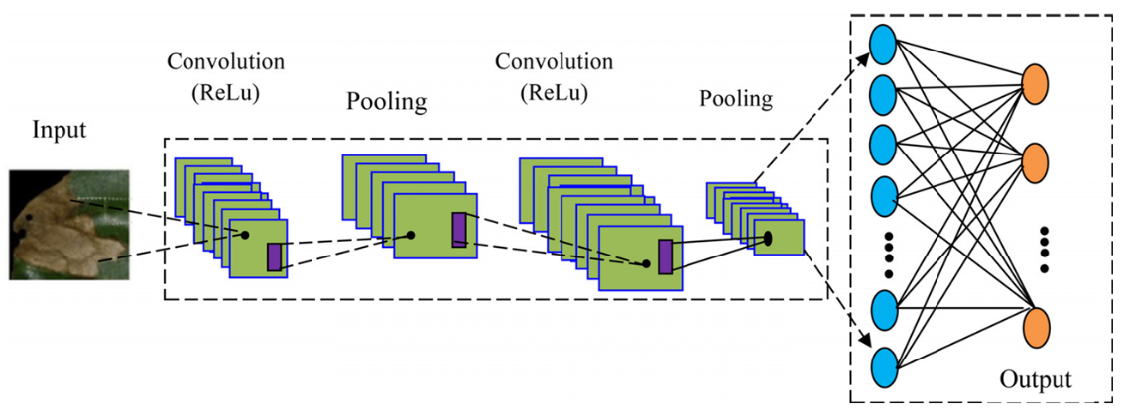

Fig. 1.8 CNN Image Processing Architecture

11`

CHAPTER 2

LITERATURE REVIEW

This section provides a critical review of the existing literature on plant disease identification and classification. Research in this area can be broadly categorized into two approaches: machine learning (ML) and deep learning (DL) [6]. Early detection of crop health issues and diseases is crucial for effective management, including the use of fungicides, disease-specific treatments, and pesticide-based vector control. Beyond disease prevention, these measures can enhance agricultural productivity. Accurately distinguishing between healthy and diseased leaves is essential for reducing crop losses and increasing yield [7].

Machine learning techniques are increasingly being used for plant disease identification, as discussed in this section (Table 1). A comparison is presented between two widely adopted approaches—deep learning (DL) and machine learning (ML)—for plant disease detection using leaf image data [8]. Previously, many image-processing techniques relied on basic machine learning architectures [9]. However, deep learning networks are progressively becoming the industry standard for pattern recognition and image analysis. This comparison evaluates both approaches under standard conditions, considering three key factors: model design, processing capacity, and training data volume.

Fig 2.1 Classification Techniques by Various Researchers

12

Deep learning techniques are proving highly effective in agricultural image analysis. Study [10] demonstrated real-time insect detection and identification in soybean crops, achieving 98.75% accuracy and a processing speed of 53 frames per second using the YoloV5 model. This was accomplished with a custom dataset of crop insects, simplifying pest management for producers. Similarly, study [11] utilized a convolutional neural network (CNN) to classify plant leaf diseases from the PlantVillage dataset, achieving approximately 98% accuracy in both training and testing. This classification covered 15 categories, including healthy leaves and various diseases caused by bacteria and fungi. Shrivastava et al. [12] utilized transfer learning with deep convolutional neural networks (CNNs) to classify rice plant diseases. Their system identified four categories: rice blast, bacterial leaf blight, sheath blight, and healthy leaves. The classification process involved CNNs for feature extraction, followed by support vector machines (SVMs) for final classification. Aderghal et al. [13] employed cross-modal transfer learning with deep CNNs to classify Alzheimer’s disease using imaging modalities. Their approach aimed to enhance accuracy and was compared favourably to existing methods. The classification relied on CNNs.

Fig 2.2 Data Augmentation Technique by Various Researchers

13

|  |  |  |  |  |  |
| --- | --- | --- | --- | --- | --- |
| **Years** | **Literature Sources** | **Methodology for selecting features** | **Classification Approach** | **Datasets** | **Accuracy (%)** |
| 2022 | Aliyu M. Abdu et al. | SVM, DL | Supervised learning | Plantvillage dataset | 95.30% |
| 2022 | Savvas Dimitriadis | Naïve Bayes | Supervised learning | Kaggle dataset | 89.20% |
| 2022 | Asma Akhtar et al. | K-Mean, KNN, RNN | Unsupervised learning | Plant leaf dataset | 87.42% |
| 2021 | Kiran R. Gavhale et al | ANN, CNN | Supervised learning | Leaf images | 91.51% |
| 2021 | Jagadeh D. Pujari et al. | PNN, SVM, GLCM | Supervised learning/unsupervised | Image Data Set | 96.51% |
| 2021 | Sharada P.Mohanty | Neural Network | Supervised learning | Image Net | 83.13% |
| 2020 | Srdjan Sladojevic | SVM, Neural Network, Decision Tree | Supervised learning | Pictures of Plant  Pictures Potato  Village Tomato  Pictures Apple  Pictures Rice | 94.31% |
| 2020 | P.Ferntions | Neural Network | Supervised learning | Alex Net, Google  Net, Over-Feat, VGG | 97% |
| 2020 | S. Sannakkiet et al. | SVM | Supervised learning | Image Dataset | 85% |
| 2019 | TejalChandi waeetet al. | ANN SVM | Supervised learning | Manual Dataset | 82.34% |
| 2019 | Yan Guo et al. | ANN SVM | Supervised learning | Plant Village | 96.45% |
| 2019 | Yan Guo et al. | CNN | Supervised learning | Apple dataset | 93.81% |

Table 2.1 Literature Review

14

|  |  |  |  |  |
| --- | --- | --- | --- | --- |
| Author | Plant Name | Bacterial Disease | Viral Disease | Fungal Disease |
| Kianat et al. 2021 [9]  Agarwal et al. 2021 [10] | Cucumber | Brown Blemnish, Angular Blemnish, Target  Blemnish | Mosaic, Yellow Blemnish | Black Blemish, Gray Mold |
| Shrivastava et al. 2019 [11]  Chen et al. 2021 [12] | Rice | Streak, Blight | Black Dwarfed Streaked | Smut False |
| Sun et al. 2021 [13] | Maize | Streak, Stalk | Crimson, Dwarf | Rust |
| Abbas et al. 2021 [14] | Tomato | Canker | Curl leaf yellow | Late/Early Blight |

Table 2.2 Distinct disease in different plants

15

|  |  |  |  |
| --- | --- | --- | --- |
| Plants | Diseases | Pathogens | Symptoms |
| Apple | Scab  Rot  Rust | PomiSpilocal  MalorumSphaeropsis  Sporangium | Brown-Gray on leaf  Dark Brown on leaf  Yellow pale on leaf |
| Cherry | Mildew | Clandestina | Gray powder on leaf |
| Corn | Gray Spot  Rust  Light blight | Cercospora  Sorghipuccinia  Tutcicasetosphaeria | Rectangle lesions  Red pustules on leaf  Elliptical lesions |
| Grape | Rot  Measles  Isariopsis blight | Bidwelliiguignardia Aleophilum  Angulata brachypus | Red borders on leaf Necrotic stripping  Coalesce lesions |
| Peach | Spot | Arboricola Xanthomonas | Clustered lesions |
| Potato | Early blight  Late blight | Solani Alternaria  Infestans phytophthora | Brown lesion  Dark greeb spot |
| Tomato | Septoria spot  Mosaic | Lycopersici  Mosaic virus | Foliage  Mottle green leaf |
| Orange | Green Citrus | Bacteria Motile | Precipitate Demolition |
| Strawberry | Scorch Fungus | Diplocarpon | Brown edges |
| Squash | Mildew | Xanthiipodosphaers | White powder |

Table 2.3 Distinct plants, their disease and responsible pathogen

16

|  |  |  |
| --- | --- | --- |
|  | Technique Used | Authors |
| Color Space Conversion | Enhancement  Filtering,  Background reduction RGB, HSV, HSI, YIQ, L*a*b, grayscale | Kaur et al. 2018 [22], |
| Image Enhancement Technique | Denoising Using mean and median filtering  Illumination variation using histogram equalization | Goncharov et. al. 2019 [23] |
| Thresholding techniques | Thresholding, Entropy, classification of diseases and pests | M. Francisco et al. 2023 [24] |
| Clustering | k-means | Kaur et al. 2018b [22],  Bashir et al. 2019 [19] |
| Feature Descriptor | GLCM, Wavelet Transform, Haralick feature, Gabor Transform, Local Binary Patterns, SURF | Bhagat & Kumar 2023 [25] |
| Texture Feature | GLCM Features | Deshapande et al. 2019 [26], |
| Color feature | Color co-occurrence matrix | Chouhan et al. 2019 [27] |
| Feature Descriptor | discrete wavelet transforms and SVM | S. M. Kiran et al. 2021 [28] |

Table 2.4 Details of techniques used by various researchers

|  |  |  |  |
| --- | --- | --- | --- |
| Author | Datasets | Techniques | Accuracy increased (%) |
| Bin et al. 2017 [48] | 1053 – 13689 | PCA | 4.00 |
| Srdjan et al. 2016 [49] | 4483 – 33469 | Rotation | 3.00 |
| Nazki et al. 2020 [50] | 2789 | ARGAN | 5.20 |
| Tain et al. 2019 [51] | TeaImage | CycleGAN | 28.00 |
| Wu et. al. 2020 [52] | GoogleNet | DCGAN | 94.33 |
| Liu et. al. 2020 [53] | Grape | LeafGAN | 94.02 |
| Lin et al. 2019 [54] | 10820 – 32460 | Radial Blur | 3.15 |
| Arnal Barbedo 2019 [55] | 1567 – 46409 | Segmentation | 12.00 |

Table 2.5 Details of data augmentation technique is used by various researchers

17

CHAPTER 3

SOFTWARE REQUIREMENT ANALYSIS

Software Requirement Analysis is the process of understanding and documenting the needs and expectations of stakeholders for a software system. It involves identifying, analyzing, and documenting the functional and non-functional requirements that the software must fulfil to meet the needs of users and other stakeholders.

3.1 Functional Requirements

3.1.1 Image Upload and Input

* Users must be able to upload images of plant leaves via a web or mobile application.
* Support for common image formats (e.g., JPEG, PNG).
* Option to capture images directly using a device's camera.

3.1.2 Image Processing and Disease Detection

* Preprocess the uploaded image (e.g., resizing, noise reduction, normalization).
* Analyze the image using trained AI models to detect and classify diseases.
* Return disease classification results with confidence scores.

3.2 System Requirements

3.2.1 AI Model and Libraries

* Model: Pretrained Convolutional Neural Networks (CNNs) such as ResNet, MobileNet, or custom-trained models.
* Libraries: TensorFlow, PyTorch, or Keras for model development.

18

3.2.1.1 Convolutional Neural Network (CNN)

A Convolutional Neural Network (CNN) is a type of deep learning algorithm primarily used for image recognition and classification tasks. CNNs are designed to automatically and adaptively learn spatial hierarchies of features from input images through layers of convolutions, pooling, and fully connected layers.

The key components of a CNN include:

* Convolutional Layers: Extract feature maps by applying filters (kernels) to the input image.
* Pooling Layers: Reduce the dimensionality of feature maps, helping to retain essential information and improve computational efficiency.
* Fully Connected Layers: Act as classifiers that process the extracted features to produce the final output (e.g., predicted class).

CNNs are widely used in applications like facial recognition, medical image analysis, object detection, and plant disease detection due to their high accuracy and ability to handle large-scale image data.

3.2.1.2 ResNet

ResNet is a deep convolutional neural network architecture introduced by Microsoft in 2015. It addresses the problem of vanishing gradients in very deep networks by using residual blocks—shortcut connections that skip one or more layers. These connections allow the network to learn identity functions, making it easier to train very deep models. ResNet has been widely used in image classification tasks and has won the ImageNet competition. Common variants include ResNet-18, ResNet-50, and ResNet-101.

3.2.1.3 MobileNet

MobileNet is a lightweight deep learning model designed for mobile and embedded devices. It uses depthwise separable convolutions to reduce the number of parameters and computational cost, making it efficient for real-time applications on devices with limited processing power. MobileNet is commonly used in mobile vision applications like face detection, object recognition, and image classification.

3.2.1.4 Tensorflow

TensorFlow is an open-source machine learning and deep learning framework developed by Google Brain.

19

It is widely used in industry and academia for building, training, and deploying machine learning models at scale. TensorFlow supports both low-level operations (like building custom models layer by layer) and high-level APIs (like Keras) for ease of development.

TensorFlow allows users to build computational graphs where operations are represented as nodes. It supports both static and dynamic graphs, though the default is static. TensorFlow excels in production deployment, offering tools like TensorFlow Serving, TensorFlow Lite (for mobile), and TensorFlow.js (for the web).

Key Features:

* Scalable for both CPUs and GPUs
* Strong support for mobile and embedded devices
* TensorBoard for visualization and model debugging
* Large community and extensive documentation

3.2.1.5 PyTorch

PyTorch is an open-source deep learning framework developed by Facebook’s AI Research (FAIR) lab. It is known for its dynamic computation graph, meaning the graph is built on-the-fly as operations are executed—making it more intuitive and easier to debug than static-graph frameworks.

PyTorch has become extremely popular among researchers and developers due to its Pythonic syntax, flexibility, and integration with other libraries. It also supports GPU acceleration for high-performance computing and has tools like TorchVision for computer vision tasks and TorchText for NLP.

Key Features:

* Dynamic computation graph (eager execution)
* Intuitive and flexible API
* Strong support for research and experimentation
* Seamless integration with NumPy and Python ecosystem
* Widely adopted in academia and increasingly in industry

3.2.1.6 Keras

Keras is a high-level neural networks API written in Python and capable of running on top of TensorFlow, Theano, or CNTK.

20

It is designed to enable fast experimentation with deep learning models. Keras simplifies the process of building and training neural networks through an easy-to-use and modular interface, making it ideal for beginners and rapid prototyping.

3.3 Cloud Services

Deployment on AWS, Azure, or Google Cloud for hosting and scalability.

3.3.1 Amazon Web Services

Amazon Web Services (AWS) is the world’s leading cloud computing platform, launched by Amazon in 2006. It offers over 200 fully featured services across computing, storage, databases, networking, machine learning, artificial intelligence, Internet of Things (IoT), and more.

Key Services:

* EC2 (Elastic Compute Cloud) – for scalable virtual servers.
* S3 (Simple Storage Service) – for object storage.
* RDS (Relational Database Service) – for managed relational databases.
* Lambda – for serverless computing.
* SageMaker – for building, training, and deploying ML models.

Advantages:

* Extensive global infrastructure with data centers across multiple regions.
* Broadest and most mature set of cloud services.
* Deep support for enterprise-grade security, compliance, and identity management.
* Strong ecosystem and marketplace.

Use Cases:

* Web and mobile app hosting
* Big data processing
* Machine learning and AI workloads
* Cloud-native application development

21

3.3.2 Microsoft Azure

Microsoft Azure, launched in 2010, is a robust and enterprise-friendly cloud platform by Microsoft. It provides a comprehensive suite of cloud services for building, testing, deploying, and managing applications through Microsoft-managed data centres.

Key Services:

* Azure Virtual Machines – for scalable compute capacity.
* Azure Blob Storage – for unstructured data storage.
* Azure SQL Database – for fully managed relational databases.
* Azure Functions – for event-driven serverless computing.
* Azure Machine Learning – for building and deploying AI models.

Advantages:

* Seamless integration with Microsoft products like Windows Server, SQL Server, Active Directory, and Office 365.
* Strong support for hybrid cloud and on-premises environments via Azure Arc.
* Excellent developer tools and SDKs through Visual Studio and .NET.
* Strong enterprise and government adoption.

Use Cases:

* Enterprise cloud migration
* Hybrid cloud deployment
* DevOps and CI/CD automation
* Artificial intelligence and data analytics

3.3.3 Google Cloud Platform

Google Cloud Platform (GCP) is Google’s suite of cloud computing services launched in 2011. It is known for its innovation in data analytics, artificial intelligence, and open-source technologies. GCP leverages Google’s core infrastructure to provide highly scalable and high-performance services.

22

Key Services:

* Compute Engine – for customizable virtual machines.
* Cloud Storage – for scalable object storage.
* BigQuery – for fast, SQL-based analytics on big data.
* Cloud Functions – for lightweight, serverless computing.
* Vertex AI – for machine learning model development and deployment.

Advantages:

* Best-in-class data analytics and ML tools.
* Strong support for Kubernetes (Google originally developed Kubernetes).
* Cost-effective and developer-friendly tools.
* Integration with open-source and multi-cloud platforms like Anthos.

Use Cases:

* Real-time data processing and analytics
* Machine learning and AI model deployment
* Containerized application development with Kubernetes
* Web and mobile app hosting

3.4 Testing Frameworks

AI Model testing: Confusion matrix, accuracy metrics

3.4.1 Confusion matrix

A Confusion Matrix is a tabular summary of classification results. It compares the predicted labels with the actual labels and helps in understanding the types of errors made by the classifier. It is especially useful in binary and multi-class classification tasks.

Structure of a Confusion Matrix (Binary Classification):

|  |  |  |
| --- | --- | --- |
|  | Predicted: Positive | Predicted: Negative |
| Actual: Positive | True Positive (TP) | False Negative (FN) |
| Actual: Negative | False Positive (FP) | True Negative (TN) |

23

Terminologies:

* True Positive (TP): Model correctly predicts the positive class.
* True Negative (TN): Model correctly predicts the negative class.
* False Positive (FP): Model incorrectly predicts positive when it's actually negative (Type I Error).
* False Negative (FN): Model incorrectly predicts negative when it's actually positive (Type II Error).

Usefulness:

* Allows deeper analysis beyond overall accuracy.
* Helps identify imbalances and misclassification trends.
* Supports calculation of several performance metrics.

3.4.2 Accuracy metrics

Using the values from the confusion matrix, several performance metrics can be calculated to measure the model's effectiveness.

Accuracy

* Indicates the overall correctness of the model.
* Can be misleading in imbalanced datasets.

Precision

* Indicates how many predicted positives were actually positive.
* Important in cases where false positives are costly (e.g., spam detection).

Recall (Sensitivity or True Positive Rate)

* Indicates how many actual positives were correctly predicted.
* Important in cases where false negatives are costly (e.g., disease detection).

F1 Score

* Harmonic mean of precision and recall.
* Balances both false positives and false negatives.

24

Specificity (True Negative Rate)

* Measures the proportion of actual negatives correctly identified.

ROC Curve and AUC

* ROC Curve (Receiver Operating Characteristic): Plots TPR vs FPR at different threshold levels.
* AUC (Area Under Curve): Measures the area under the ROC curve; higher AUC indicates better model performance.

3.4.3 Robustness tests

Robustness testing evaluates how well a model maintains its performance under varying conditions or in the presence of noise and uncertainty. It ensures that the model is not only accurate on test data but also reliable in real-world scenarios.

Types of Robustness Tests:

Noise Tolerance Test

* Test model’s performance after injecting noise into the input data.
* Useful in image, audio, or sensor data applications.

Adversarial Attacks

* Apply small, intentional perturbations to data to see if the model misclassifies.
* Ensures security and trustworthiness of models in critical applications.

Cross-Domain or Cross-Dataset Testing

* Evaluate the model on a slightly different dataset (different distribution, same task).
* Assesses model generalization.

25

Data Augmentation Tests

* Use augmented or synthetic data (rotation, flipping, scaling in images) to test how consistent the model’s predictions are.

Model Drift Testing

* Over time, the data distribution may change (concept drift). Testing for robustness ensures the model remains reliable over time.

3.5 Other requirements

3.5.1 Integration Requirements

External APIs: Agricultural databases for updated disease management practices.

Data Sources: Integration with research datasets for model training and validation.

3.5.2 Hardware Requirements

Local Machine Requirements: A machine with at least 8GB RAM and a processor (Intel i3/i5/i7 or AMD Ryzen 5/7).

26

CHAPTER 4

SYSTEM ANALYSIS & DESIGN

4.1 Class Designs – Description

Class design refers to the blueprint or template for creating objects in an object-oriented program. It defines the attributes (data) and methods (functions) of each class that will be part of the system. In this project, class designs ensure a modular, reusable, and maintainable architecture.

* Purpose: To model real-world entities like users, images, classifiers, and diseases.
* Example: A DiseaseClassifier class might contain a method to load the trained model and another method to make predictions based on an input image.

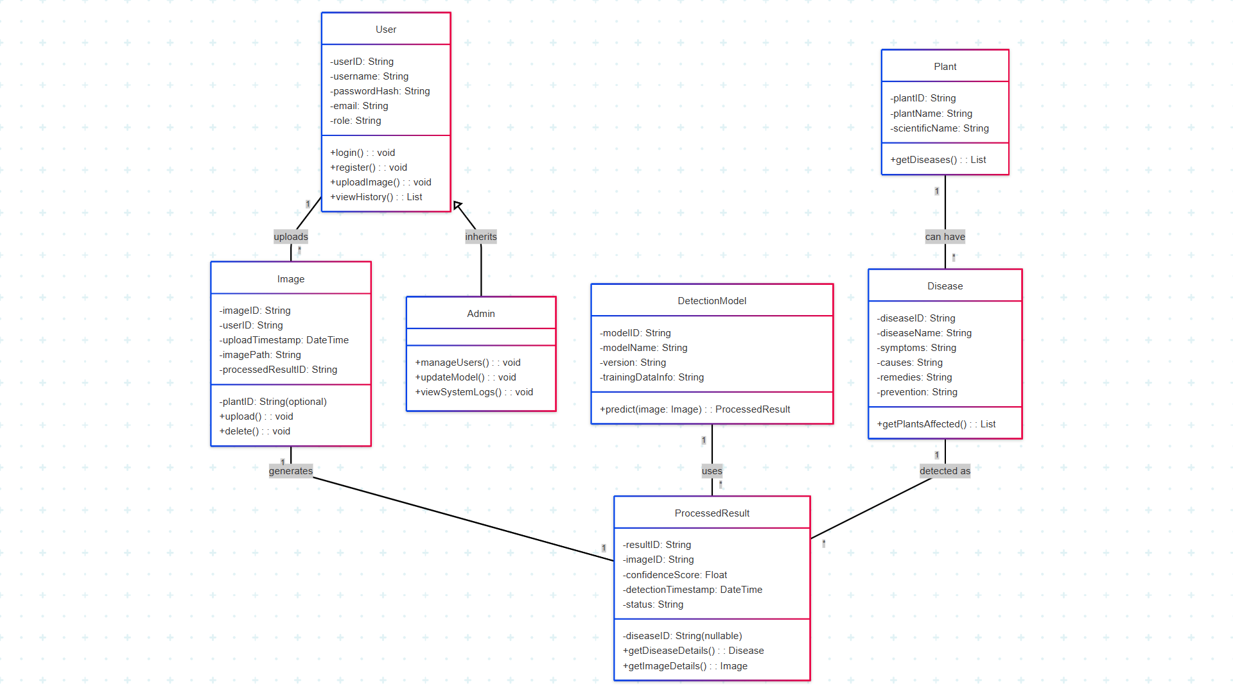

Fig 4.1 Class Diagram

27

4.2 Sequence Diagrams – Description

A sequence diagram is a UML behavioral diagram that shows how objects interact in a time sequence. It emphasizes the order in which messages are sent between system components.

* Purpose: To visualize the interaction between the user, system components (e.g., image processor, classifier), and the database over time.
* 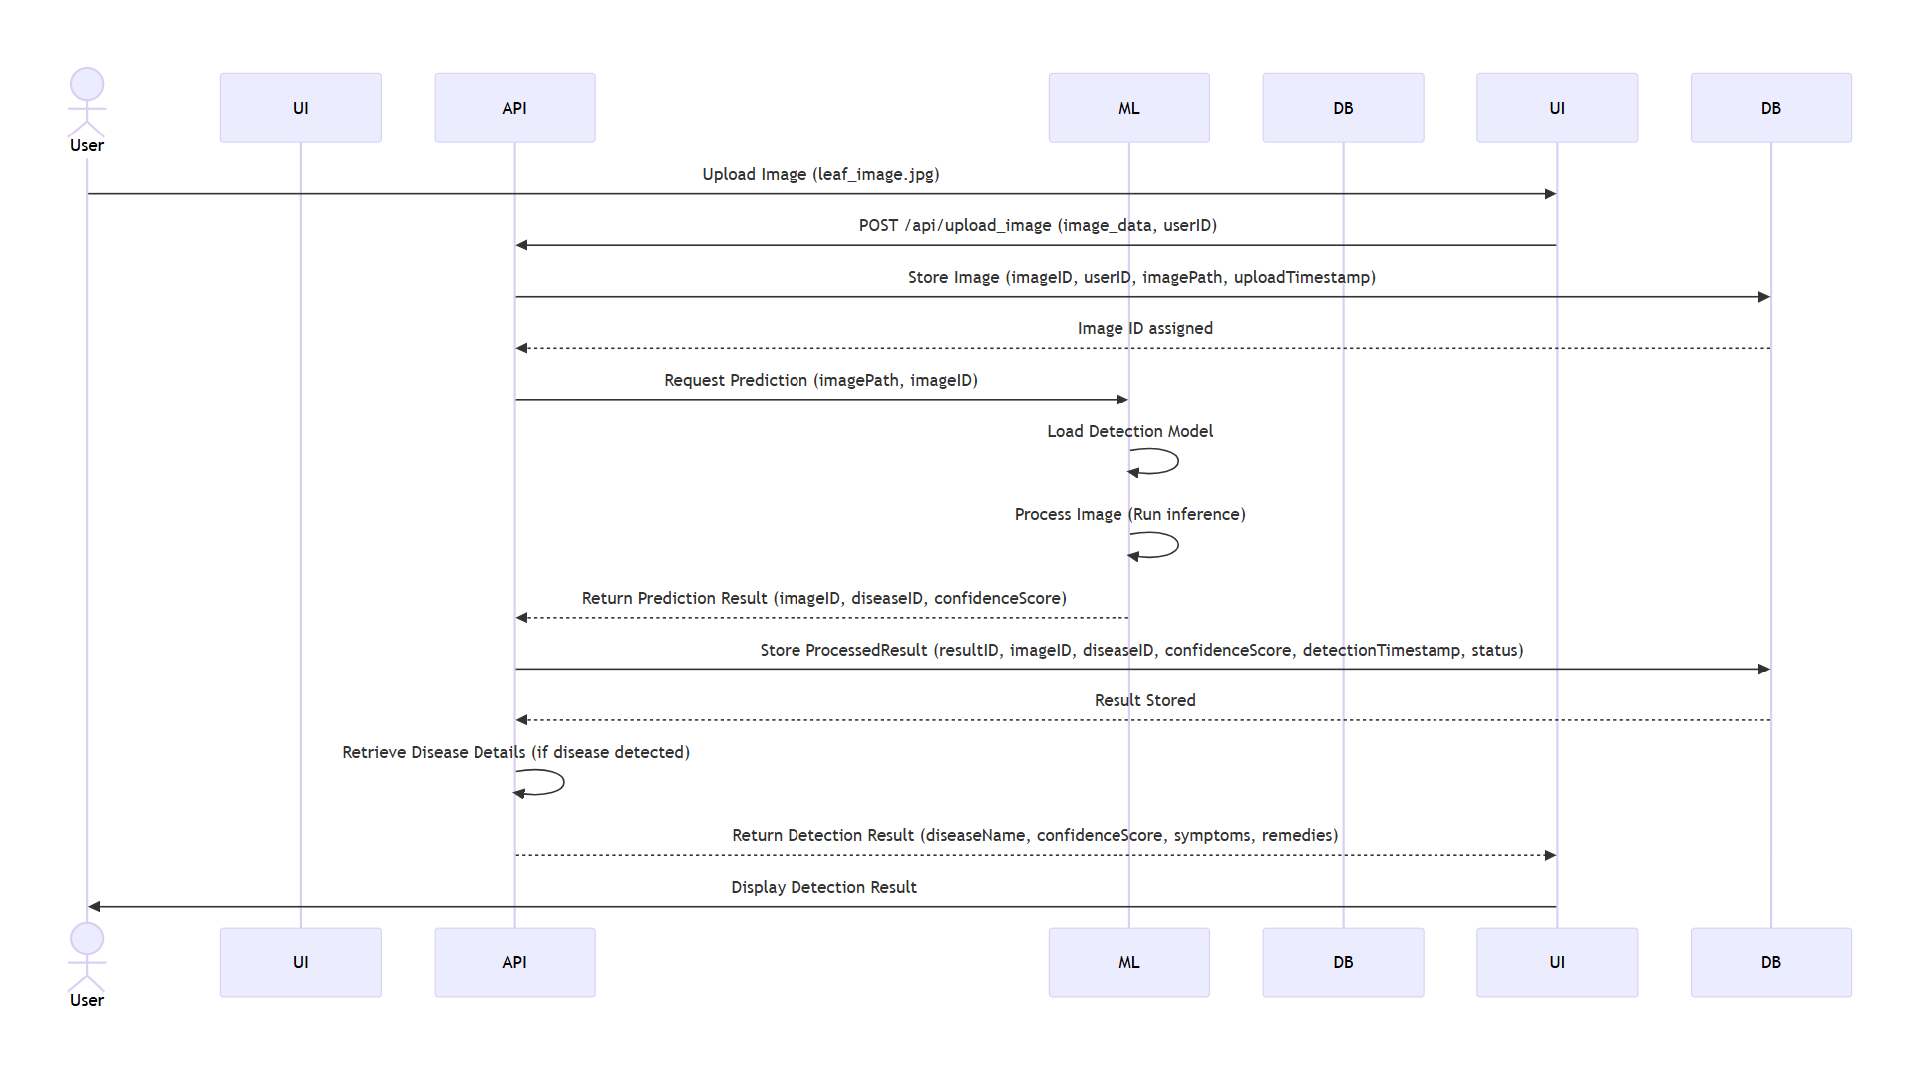Example: The flow from image upload → preprocessing → prediction → fetching disease info → displaying results is captured step-by-step.

Fig 4.2 Sequence Diagram

4.3 Activity Diagrams – Description

Activity diagrams represent workflow or business processes. They show the flow of control from one activity to another and are useful for modelling the logic of complex operations.

28

* Purpose: To describe the dynamic aspects of the system, especially processes like disease detection and result generation.
* Example: An activity diagram might illustrate how the image goes through preprocessing, model prediction, disease info retrieval, and result display.

4.4 Data Flow Diagrams (DFDs) – Description

A DFD illustrates how data flows through a system. It shows data sources, processes, storage, and destinations, helping to understand the system’s input, processing, and output.

* Purpose: To represent the flow of data from user inputs (e.g., image upload) to the final output (e.g., disease result).
* Example: A level-1 DFD might show processes like "Upload Image", "Run Classifier", and "Fetch Disease Info", with data stores for user history and disease metadata.

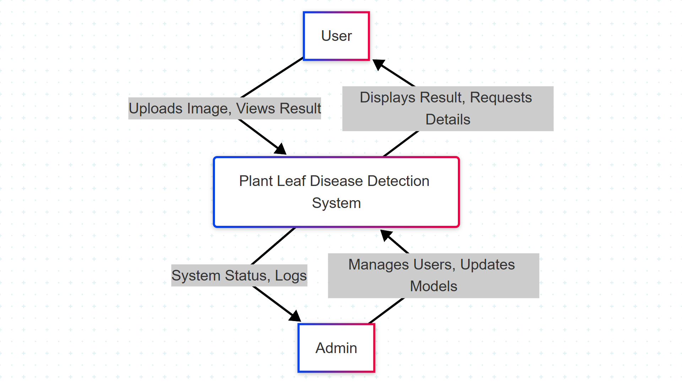

Fig 4.3 DFD Level – 0

29

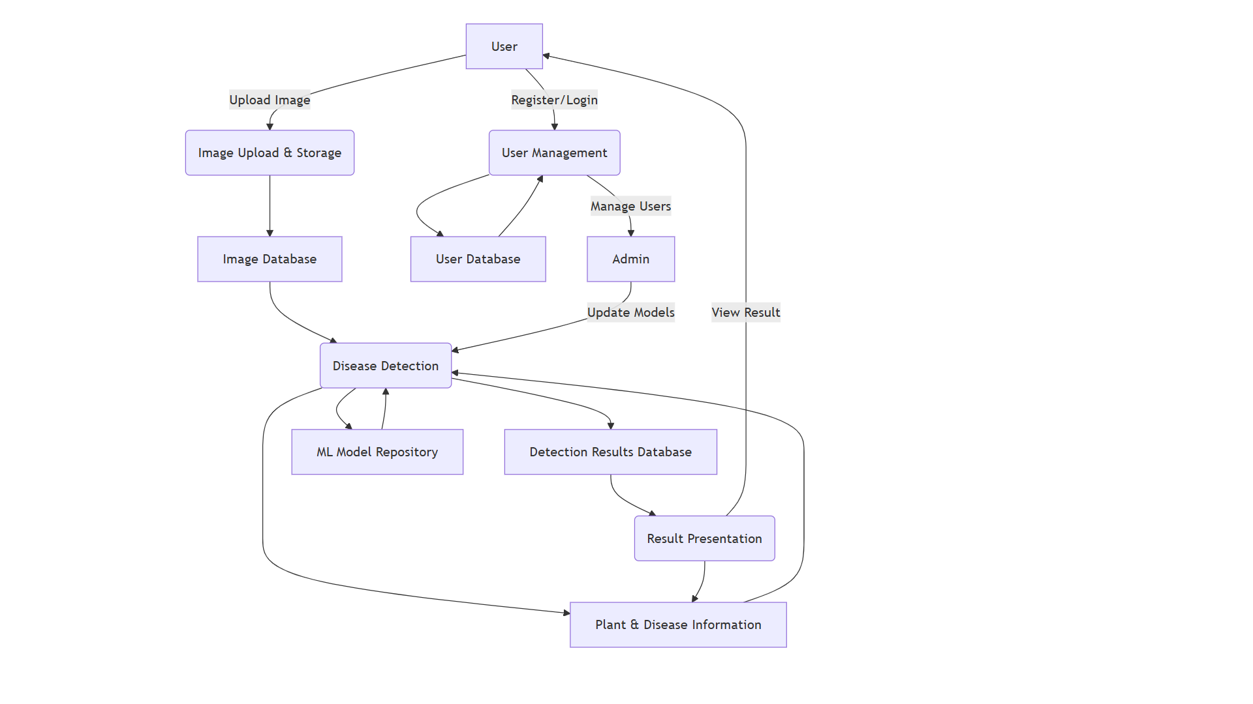

Fig 4.4 DFD Level – 1

4.5 Database Design

4.5.1 Entity-Relationship (E-R) Diagrams – Description

An ER diagram is a visual representation of the database schema. It shows entities (tables), their attributes (columns), and relationships among them.

* Purpose: To structure the project’s database design by identifying how data is stored and connected.
* Example: Entities like Users, Predictions, and Diseases are connected, showing that each user can make multiple predictions and each prediction relates to one disease.

30

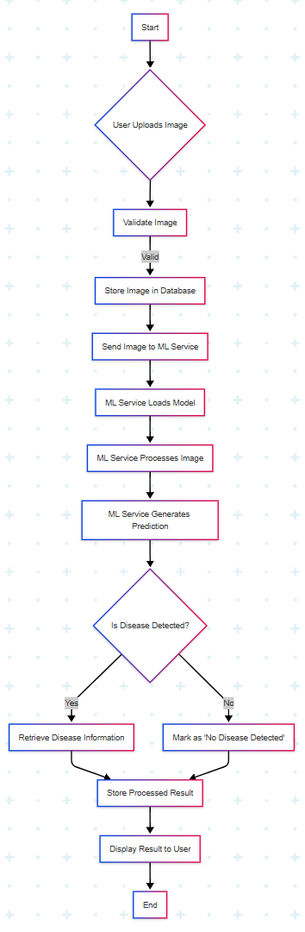

Fig 4.5 Activity Diagram

31

CHAPTER 5

IMAGE PROCESSING

Image processing involves transforming a physical image into a digital form, enabling various operations such as enhancement, analysis, or feature extraction. In image science, it refers to any technique where the input is an image—such as a photograph or a video frame—and the output may be a transformed image or a set of extracted features.

Although analog and optical techniques exist, digital image processing is the most widely used method. The process typically begins with capturing an image through devices like digital cameras or optical scanners. This digital image is then subjected to processing to enhance its quality or extract significant information.

This stage plays a critical role in many deep learning and computer vision systems, where proper preprocessing can greatly improve model effectiveness. In the entertainment sector, image processing is frequently used for editing tasks, such as object removal or insertion in images.

Images are usually treated as two-dimensional signals and are analysed using standard signal processing methods. Specific areas within an image, called Regions of Interest (ROIs), are often studied separately as they tend to contain key visual elements.

One practical example is defect detection, where image processing techniques help in identifying surface imperfections by focusing on the affected areas. Consequently, image processing has seen rapid growth across various industries, particularly in manufacturing.

The image processing workflow generally includes three primary steps:

1. Image acquisition using digital devices.
2. Image analysis and manipulation, which includes tasks like data compression, image enhancement, and detection of patterns that may not be visible to the human eye.
3. Output generation, where either a processed image or an analytical report is produced.

32

5.1 Introduction to Image Processing

5.1.1 Objective of Image Processing

Image processing serves several key functions, which can be categorized into five main areas:

1. Visualization – Making objects visible that are not easily seen.
2. Image enhancement and restoration – Improving image quality.
3. Pattern measurement – Determining the dimensions of specific elements in an image.
4. Image recognition – Identifying and classifying objects within an image.

5.1.2 Image Types

An image can be defined as a two-dimensional function where the spatial coordinates (x, y) indicate position, and the intensity value at each point denotes brightness or darkness at that location.

When both the spatial coordinates and intensity values are discretized, the result is known as a digital image. Digital image processing refers to the use of a computer to manipulate or analyze these digital images.

In a digital image, each pixel represents a specific location on the 2D grid and contains one or more numeric values, often called samples, which reflect its intensity or color.

In programming environments such as Python, image processing generally works with two main image types:

* Binary images – Each pixel is either black or white.
* Grayscale images – Pixels have varying shades of grey to represent intensity levels.

5.1.2.1 Binary Image

Binary images are stored as logical arrays and are also referred to as bi-level or two-level images—commonly known as black and white (B&W) images. Some input/output devices, such as laser printers and certain computer monitors, are designed specifically to handle only bi-level images. As illustrated in Figure 4.1, a binary image is composed of pixels that can take on only one of two distinct values: 0 or 1. These values represent black and white, respectively.

33



Fig 5.1 Binary Image

5.1.2.2 Grayscale Images

Grayscale images consist of varying shades from black (at the lowest intensity) to white (at the highest). Each pixel in a grayscale image holds a single intensity value, reflecting the light level at that point.

Such images are typically created by measuring the intensity of light across a single band of the electromagnetic spectrum, such as infrared, visible light, or ultraviolet. The pixel values represent these measurements.

In most digital systems, grayscale images are stored with 8 bits per pixel, allowing for 256 different shades of gray. This makes them ideal for visual display and detailed analysis.

A sample grayscale image is presented in Figure 5.2.

Fig 5.2 Gray Scale Image

5.1.3 Types of Image Processing

34

Image processing can be broadly categorized into two types:

* Analog Image Processing
* Digital Image Processing

5.1.3.1 Analog Image Processing

Analog image processing involves the manipulation of two-dimensional analog signals, often in physical formats such as printed images or photographs. It is mainly used in the fields of image science and computer science.

Unlike digital processing, analog techniques rely heavily on visual interpretation by experts. The process depends on the observer’s knowledge, experience, and the specific characteristics of the image being analyzed.

Here, human judgment plays a critical role in evaluating visual data, often with minimal technological assistance.

5.1.3.2 Digital Image Processing

Digital image processing enables the manipulation of images using computer-based techniques. It is especially important in fields like satellite imaging, where raw data may contain various imperfections that must be corrected.

The digital process generally includes three main stages:

1. Pre-processing – Removing noise and correcting distortions.
2. Enhancement and display – Improving visual quality for better interpretation.
3. Information extraction – Identifying and isolating useful features from the image.

This method starts by converting a physical image into a digital form using devices like scanner-digitizers. Once digitized, the image can undergo numerous computational operations to produce an enhanced or modified version.

In essence, digital image processing refers to the application of algorithmic operations to a numerical image representation to generate the desired outcome.

5.2 Methodology for image processing

35

5.2.1 Data Preprocessing

The first step in the pipeline is data preprocessing.  
During this phase, 800 leaf images categorized as *Diseased* and *Healthy* are loaded into the system for training. The OpenCV library in Python is used to convert images from RGB to BGR format, as OpenCV processes images in the BGR color space.

5.2.2 Image Segmentation

Image segmentation involves partitioning a digital image into multiple segments or regions (sets of pixels). Each pixel is assigned a label such that pixels with the same label share certain characteristics.

5.2.3 Feature Extraction (Feature Mining)

Feature mining converts raw image data into mathematical features that preserve essential information. This approach significantly improves performance compared to applying machine learning directly to raw data.

Three types of descriptors are used for feature extraction:

* Color Features: Color Histogram
* Shape Features: Hu Moments
* Texture Features: Haralick Texture

5.2.4 Model Training

To prepare the data for model training:

* Image labels are encoded numerically based on their folder classification.
* The dataset is split into 80% for training and 20% for testing.
* Feature scaling is applied to standardize values with different magnitudes.
* Extracted features are saved in an HDF5 file for efficient access.

Five machine learning models are trained using the processed data:

* a) Random Forest
* b) Logistic Regression
* c) K-Nearest Neighbors (KNN)
* d) Naive Bayes
* e) Support Vector Machine (SVM)

36



Data Collection

Data Preprocessing

Model Selection

Model Implementation

Model Training

Model Evaluation

Deployment

Fig 5.3 Flow Chart

5.2.5 Model Training and Evaluation

The dataset was split into 80% training, 10% validation, and 10% testing. All models were trained using TensorFlow and PyTorch frameworks. Models were assessed using the following performance metrics:

- Accuracy: The accuracy score of a model, often known as accuracy, is a classification statistic in DL and ML techniques that represents the proportion of correct predictions made by the model. [19]

- Precision: Precision is defined as the ability to identify only relevant objects. It is defined as the ratio of correctly classified positive outputs to total positive outputs.

37

- Recall: A model’s recall is defined as the model’s ability to correctly identify True Positives. It is defined as the ratio of correctly classified positive outputs to correctly classified outputs.

- F1 – Score: The f1 score is also introduced to assess the model’s accuracy. The f1-score considers both the model’s precision and recall [20]

$$F1-Score=\frac{2(Precision*Recall)}{Precision+Recall}$$

5.2.6 Deployment on Local Web Application

A Flask-based web application was developed to enable real-time plant disease detection using the trained models.

- Frontend: HTML, CSS, JavaScript.

- Backend: Python (Flask) for model inference.

- User Input: Users can upload leaf images for instant classification.

5.3 Introduction to Machine Learning

Machine learning is a subset of Artificial Intelligence (AI) that focuses on recognizing patterns in data and developing models that are both intelligent and practical. In conventional computing, outputs are generated based on explicitly defined instructions. Machine learning, however, uses statistical techniques to allow systems to learn from input data and generate outputs within a specific range.

Machine learning tasks are commonly categorized into three major types, based on how the model learns and the kind of feedback it receives:

* a) Supervised Learning
* b) Unsupervised Learning
* c) Reinforcement Learning

a) Supervised Learning

In supervised learning, a model is built from a dataset that includes both input features and corresponding output labels.

38

Each data instance is typically represented as a feature vector, and the entire training dataset is structured as a matrix. The model learns to map inputs to outputs by optimizing an objective function, allowing it to generalize to new, unseen data.

b) Unsupervised Learning

Unsupervised learning deals with data that does not have labeled outputs. These algorithms identify underlying structures, patterns, or clusters within the dataset. Without supervision, the model detects inherent relationships in the data. A common application is clustering, where data points are grouped based on similarity.

c) Reinforcement Learning

Reinforcement learning involves training an agent to make decisions by interacting with its environment to maximize cumulative rewards. The environment is often modelled as a Markov Decision Process (MDP).

5.3.1 Algorithms Used

5.3.1.1 Random Forest Classifier

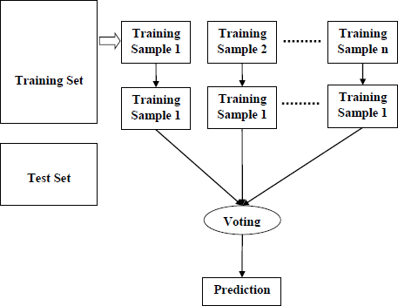Random Forest (RF) is a widely used supervised learning algorithm suitable for both classification and regression tasks. Based on ensemble learning, it constructs multiple decision trees and aggregates their predictions to improve accuracy and reduce overfitting.

Fig 5.4 Working of Random Forest Algorithm

39

Working Steps:

1. Randomly select *K* data points from the training set.
2. Build a decision tree based on these selected points.
3. Define the number *N* of trees to be constructed.
4. Repeat steps 1–2 *N* times.
5. For a new data point, aggregate predictions from all trees and choose the class with the majority vote.

5.3.1.2 Logistic Regression

Logistic Regression is a fundamental supervised learning algorithm used for binary classification. It predicts the probability of an instance belonging to a particular class (e.g., 0 or 1). Rather than outputting discrete values, it provides probabilistic estimates between 0 and 1 using a logistic (sigmoid) function.

5.3.1.3 Support Vector Machine (SVM)

Support Vector Machine is a powerful supervised learning algorithm primarily used for classification, though it can also be applied to regression.

SVM aims to find the optimal hyperplane that best separates the data points of different classes in high-dimensional space.

5.3.1.4 K-Nearest Neighbors (KNN)

K-Nearest Neighbors is a simple yet effective supervised learning algorithm used for both classification and regression, though it is more commonly applied to classification problems.

KNN works by:

* Comparing a new data point with existing labeled data.
* Finding the K most similar instances (neighbors).
* Assigning the new point to the most frequent class among those neighbors.

5.3.1.5 Naive Bayes

Naive Bayes is a supervised learning algorithm based on Bayes' Theorem, often used for text classification and spam detection.

Despite its simplicity, Naive Bayes is highly effective. It assumes independence among features, which allows it to make fast and reliable predictions even on large datasets.

5.4 Technologies Used

40

5.4.1 Python

Python is a high-level, general-purpose programming language known for its simplicity and readability. It is an interpreted language that uses indentation to define code structure, enhancing clarity and maintainability. Originally developed by Guido van Rossum as a successor to the ABC language, Python was first released in 1991. Python also supports advanced concepts such as metaprogramming and aspect-oriented programming. Through extensions, it even allows for logic programming and design-by-contract paradigms.

5.4.2 Python Libraries

One of Python’s greatest strengths is its comprehensive standard library, which includes tools and modules for a wide range of programming tasks. These include:

* Internet protocols (e.g., HTTP)
* GUI development
* Database access
* Regular expressions
* Numerical computations
* Unit testing

Modules like the Web Server Gateway Interface (WSGI) adhere to PEP specifications, while most others are defined by their source code, documentation, and test suites.

5.4.3 Pandas

Pandas is a powerful Python library designed for data manipulation and analysis. It provides flexible data structures such as DataFrames for handling structured data and time series.

Key Features:

* DataFrame object with integrated indexing for structured data
* Support for reading/writing data from various file formats
* Efficient handling of missing data

Developed by Wes McKinney in 2008 during his time at AQR Capital, the name “pandas” is derived from “panel data” and is also a play on “Python data analysis.”

41

It is open-source software released under the BSD license.

5.4.4 Scikit-learn

Scikit-learn is an open-source machine learning library for Python that supports a wide array of algorithms for classification, regression, and clustering. These include:

* Support Vector Machines (SVM)
* Random Forests
* K-Means Clustering
* DBSCAN

It is designed to work seamlessly with other Python libraries like NumPy and SciPy, utilizing their capabilities for high-performance numerical computations.

5.4.5 NumPy

NumPy (Numerical Python) is a foundational library for numerical computing in Python. It offers support for large, multi-dimensional arrays and matrices, along with a collection of high-level mathematical functions to operate on them efficiently.

Key Features:

* Optimized operations on arrays and matrices
* Fast computation using vectorization
* Interoperability with C and Fortran code

Developed by Jim Hugunin and other contributors, NumPy was designed to overcome performance issues of interpreted Python by providing highly efficient array operations.

42

CHAPTER 6

METHODOLOGY

6.1 Introduction

Globally, there are approximately 570 million farms, and over 90% of the world's population is connected to agriculture in some way. Farmers are responsible for producing nearly 80% of the food consumed worldwide. However, crop diseases continue to pose a significant threat to yield and quality in large-scale agriculture. These diseases can be caused by various pathogens such as bacteria, viruses, nematodes, and fungi, affecting both the visible and hidden parts of plants.

Additional factors, including climate change and the decline of pollinators, further impact food production, threatening farmers' incomes and global food security. To manage plant diseases, farmers often invest considerable time, money, and resources. Given the increasing environmental changes, early identification and diagnosis of plant diseases are more important than ever.

Accurately identifying disease types and understanding how to manage them remain persistent challenges in agriculture. Some plant diseases cannot be diagnosed solely through visible symptoms, making precise detection essential—not just for disease control but also for ensuring the sustainability of agriculture.

Early intervention using fungicides, pesticides, or disease-specific chemicals is more effective when an early warning system is in place. Recently, smartphone-based disease detection has become increasingly viable, thanks to the widespread availability of smartphones and advancements in machine learning and deep learning. Many studies have explored these methods, showing that traditional and modern machine learning techniques can significantly improve plant disease identification and classification.

6.1.1 Convolutional Neural Networks (CNN)

In image classification, images are interpreted as raw pixel data and categorized as objects. CNNs (Convolutional Neural Networks) help extract meaningful features from these raw images for accurate classification. Unlike traditional image recognition methods—where features must be defined manually—CNNs automatically learn and extract relevant features from raw data through training.

43

6.1.2 Transfer Learning

Transfer learning leverages a pre-trained model from one task as a starting point for a new but related task. This technique is particularly useful when the new task lacks sufficient data or when training a model from scratch is impractical due to high computational costs and time. By using the features learned from the initial task, transfer learning enables quicker convergence, better generalization, and improved performance in the new task. Pre-trained models such as AlexNet, InceptionNet, and VGG16 are often fine-tuned by modifying their final classification layers for new use cases.

6.1.2.1 Importance of Transfer Learning

Transfer learning is essential in scenarios where the target problem is complex and requires significant training resources. It allows the reuse of knowledge gained from large datasets, reducing both the amount of required data and the time needed for training a model on a new but related problem.

6.1.2.2 Benefits of Transfer Learning

* Faster Learning: The model already recognizes general patterns, leading to quicker and more efficient learning.
* Improved Accuracy: Leveraging prior knowledge often results in better performance on the target task.
* Handling Small Datasets: Transfer learning helps mitigate overfitting by using already-learned features from large-scale datasets.

6.1.3 ResNet50

ResNet50, short for "Residual Network with 50 layers," is a powerful deep learning model that addresses the limitations of traditional CNNs, particularly the vanishing gradient problem. Introduced by Microsoft in 2015, ResNet50 won the ImageNet competition that year and is widely regarded as one of the most effective pre-trained models for image classification—including plant disease detection.

ResNet allows for the training of very deep neural networks through the use of skip connections, which bypass one or more layers and feed the output of an earlier layer directly into a later one. This enables the model to retain essential features and avoid gradient degradation during training.

6.1.3.1 Residual Block

44

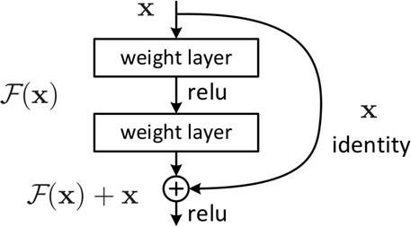The fundamental building block of ResNet is the residual block. It works by summing the input x and the output of a layer f(x):

Fig 6.1 Residual Block

6.1.3.2 ResNet50 Architecture Overview

ResNet50 comprises the following:

* A 7×7 convolution layer with 64 filters, stride 2
* A max-pooling layer with stride 2
* Convolutional and identity blocks with:
  + 1×1, 3×3, and 1×1 convolution layers of varying filter sizes
  + Repeated layer structures:
    - 3 blocks of [64, 64, 256]
    - 4 blocks of [128, 128, 512]
    - 6 blocks of [256, 256, 1024]
    - 3 blocks of [512, 512, 2048]

Types of Blocks:

* Identity Block: Used when input and output dimensions are the same.
* Convolutional Block: Used when dimensions differ, including a 2D convolution to align them.

45

Each convolutional and identity block contains three convolutional layers, contributing to the model’s total of 25 million trainable parameters.

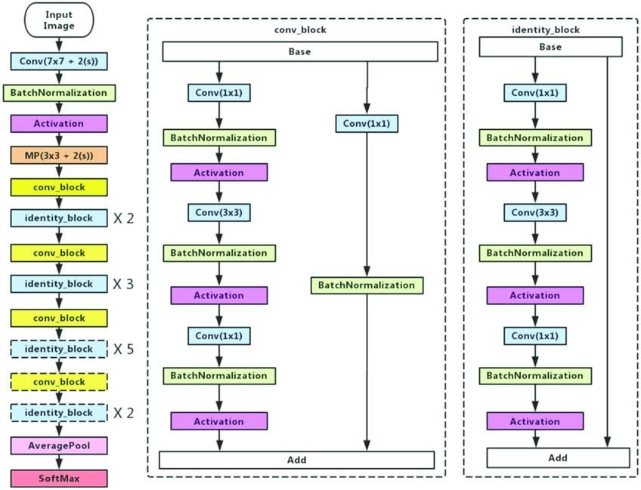

Fig 6.2 Block Diagram of ResNet50

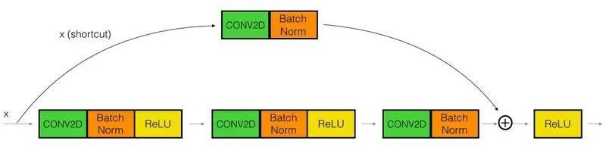

Fig 6.3 Convolutional Block

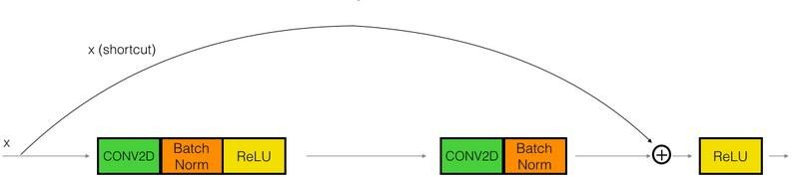

Fig 6.4 Identity Block

46

6.1.3.3 Key Features of ResNet50

* Efficient Deep Learning: Capable of training extremely deep networks (even over 100 layers) without increasing training error.
* Skip Connections: Help preserve learned features and avoid vanishing gradients.
* Fast Training: Due to reduced complexity in each block and optimized structure.

6.1.3.4 Advantages of ResNet

* Easily trains very deep networks without increasing error rates.
* Solves the vanishing gradient problem through identity mappings.
* 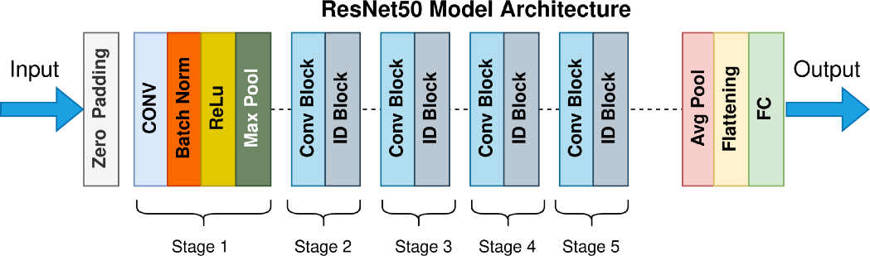Efficient in feature reuse, leading to better performance in tasks like plant disease detection.

Fig 6.5 ResNet50 Architecture

6.2 The Dataset

6.2.1 Training Dataset:

The training dataset is the primary subset of the original data used to train and fit the machine learning (ML) model. During this phase, the model learns how to make predictions for a given task by processing the input data. In unsupervised learning, the dataset consists of unlabelled data points, meaning the model must identify patterns without any predefined outputs.

47

On the other hand, supervised learning involves labeled data, where each input is associated with a corresponding output. This helps the model learn to map inputs to predictions effectively. The quality and relevance of the training dataset significantly influence the model’s accuracy and prediction capability.

6.2.2 Testing Dataset:

Once the model has been trained on the training dataset, it must be evaluated using a testing dataset. This dataset helps assess the model’s performance and ensures it can generalize effectively to unseen or new data.

The testing dataset is a distinct subset of the original data, separate from the training set. Although it shares similar features and class distributions, it has not been used during the training phase. It acts as a benchmark to test how well the model performs in real-world scenarios.

6.2.3 Importance of Splitting the Dataset:

Splitting the dataset into training and testing sets is a crucial step in data preprocessing.

This division ensures that the model's performance can be evaluated reliably and that the results are not biased by the training data.

The idea is to train the model on one portion of the data and validate its performance on a separate portion. If both sets are not distinct, the model may memorize patterns from the training data, failing to generalize to new data—resulting in poor real-world performance.

6.2.4 Differences Between Training Data and Testing Data:

* Purpose: Training data is used to build and train the model, while testing data is used to evaluate the model's performance and generalization ability.
* Size: The training set is typically larger than the testing set. Common train-test splits include 80:20, 70:30, or 90:10 ratios.

6.3 Image Pre-Processing

Before images can be used in machine learning models, they must undergo pre-processing. This involves adjusting characteristics such as color, size, and orientation to improve image quality and enhance their suitability for analysis.

6.3.1 Importance of Image Pre-Processing

48

Pre-processing is a critical step for preparing image data to be used as input in machine learning models. For example, convolutional neural networks (CNNs) require all input images to be of the same size.

If the input images are too large, resizing them can significantly reduce training time without compromising performance.

6.3.2 Criteria for Image Pre-Processing

* For optimal results in machine learning projects, data must be in an appropriate format. Some algorithms, such as Random Forest, do not support missing values, so they must be handled during pre-processing.
* A dataset may be structured to support multiple machine learning or deep learning algorithms, allowing for a comparison of outputs and selection of the best-performing model.

6.3.3 Common Image Pre-Processing Techniques

1. Grayscale Conversion

This process converts colored images into black-and-white (grayscale) format. It reduces computational complexity since most image recognition tasks do not require color information. Converting to grayscale decreases the number of pixels and simplifies calculations.

1. Standardization (Normalization)

Also known as rescaling, this process adjusts pixel values to a predefined range—typically between 0 and 1. This ensures uniformity across all images, helping to maintain consistent performance and learning rates during training. It also prevents any one image from disproportionately influencing the model due to having a larger pixel value range.

1. Data Augmentation

Data augmentation increases the variety and size of the dataset by applying small modifications to existing images, such as flipping, rotating, cropping, or shearing. This helps prevent the model from overfitting by enabling it to learn more robust features.

1. Image Rescaling/Standardizing

Resizing images ensures they are consistent in dimensions. Additionally, converting pixel values to a mean of zero improves data consistency and quality, enhancing the model’s learning process.

49

6.3.4 Steps for Loading a Custom Dataset for Deep Learning Models

1. Read the image file: Acceptable formats include JPEG, BMP, etc.
2. Resize the image: Match the dimensions required by the model input layer.
3. Convert pixel data: Cast pixel values to float data type.
4. Normalize pixel values: Scale pixel intensities from the 0–255 range down to 0–1.
5. Convert the data format: Ensure the image is represented as either a NumPy array or a tensor.

6.4 Data Augmentation

Data augmentation is a technique used in machine learning and deep learning to increase the volume and diversity of training data. It involves generating new training samples by applying various transformations to existing data—such as flipping, rotating, scaling, and cropping. The primary aim of this technique is to improve model performance and generalization by exposing the model to a broader range of scenarios.

By simulating different variations, data augmentation helps the model recognize patterns from various perspectives, lighting conditions, and orientations. It also helps reduce overfitting by supplying more diverse training examples.

6.4.1 Steps in Image Data Augmentation

There is no universal set of augmentation steps that guarantees improved model performance. In some cases, certain augmentations may even degrade performance, depending on the nature of the task.

1. Grayscale Conversion

Converting coloured images to grayscale simplifies image data and reduces the input dimensions from three channels to one. This not only reduces computational complexity but also forces the model to focus on structural and shape-based features rather than color.

1. Random Flips

Flipping images horizontally or vertically helps the model learn that objects can appear in different orientations. However, in tasks where orientation is important—such as reading text—flipping may not be appropriate.

50

1. Random Rotations

This is crucial for applications where the orientation of the object can vary, such as mobile applications. However, rotation may result in loss of image data around the edges and requires careful handling to preserve important features.

1. Random Brightness Adjustments

Adjusting image brightness randomly helps the model adapt to variations in lighting conditions. It simulates how the same object might appear under different illumination levels.

6.4.2 Image Augmentation Using Keras

The ImageDataGenerator class in Keras provides a convenient and efficient way to perform image augmentation in real-time during model training. It supports a variety of transformations such as normalization, rotation, brightness adjustments, and more.

6.4.2.1 Common Techniques in ImageDataGenerator

1. Random Rotation

Images can be randomly rotated within a specified range (0° to 360°). Any empty pixels created as a result of rotation are filled based on the fill_mode parameter, which defaults to 'nearest'.

1. Random Shifting

This involves translating the image either horizontally or vertically. The parameters width_shift_range and height_shift_range control the extent of the shift, which can be a float (fraction of the image size) or an integer (number of pixels).

1. Random Flipping

Images can be flipped horizontally (horizontal_flip=True) or vertically (vertical_flip=True). This is effective for many object recognition tasks, though care should be taken with objects that have orientation-specific meanings.

1. Random Zooming

Zooming in or out is controlled by the zoom_range parameter. If a float is provided, the zoom occurs within [1 - zoom_range, 1 + zoom_range]. This helps the model generalize to different scales of the object.

51

6.4.2.2 Methods in ImageDataGenerator

1. flow_from_directory()  
   This method loads images directly from a directory and applies augmentations on-the-fly. It expects images to be organized into subfolders by class. Key parameters include:
   * directory: Path to the main folder containing class subfolders.
   * target_size: Desired image size.
   * color_mode: 'rgb' for color images or 'grayscale' for black-and-white.
   * batch_size: Number of images per batch.
2. flow_from_dataframe()  
   This method loads images based on file paths and labels specified in a Pandas DataFrame. It's especially useful when images are stored in a single folder. Key parameters include:
   * dataframe: Contains file names and labels.
   * directory: Path to the folder containing images.
   * x_col: Column name with image file names.
   * y_col: Column name with labels.
   * class_mode: 'binary' or 'categorical' depending on the task.

6.5 Feature Extraction Using ResNet50

Feature extraction is a critical step in the dimensionality reduction process, where raw data is transformed into a more compact and manageable format. This is especially useful when working with high-dimensional datasets that contain a vast number of variables, which can demand extensive computational resources.

Feature extraction helps by isolating the most significant features and transforming the data into a lower-dimensional space, while still preserving the most relevant information.

6.5.1 Importance of Feature Extraction

When dealing with large datasets, it becomes essential to minimize computational load without compromising on the quality of information. Feature extraction plays a key role in achieving this by reducing data redundancy and highlighting the most important patterns.

52

6.5.2 Constructing the ResNet50 Model

ResNet50, a powerful convolutional neural network architecture pre-trained on ImageNet, is commonly used for feature extraction in deep learning workflows. It can be initialized using the following code:

tf.keras.applications.resnet50.ResNet50(

include_top=False,

weights='imagenet',

input_tensor=None,

input_shape=None,

pooling=None,

classes=14,

**kwargs

)

6.6 Training the Model

Training of deep learning models in Keras can be performed using either model.fit() or model.fit_generator() (note: in modern Keras, fit() now also supports generators). Both serve the purpose of fitting the model to training data, but their usage depends on the dataset size and augmentation needs:

* model.fit() is used when the dataset fits entirely into memory and no augmentation is required.
* model.fit_generator() is suited for large datasets and when using real-time data augmentation via generators.

Training Using model.fit()

After building the model, training is initiated by passing an image data iterator to the fit() function. The iterator may include augmented images generated in real-time. The model learns from data provided in batches and updates weights accordingly.

53

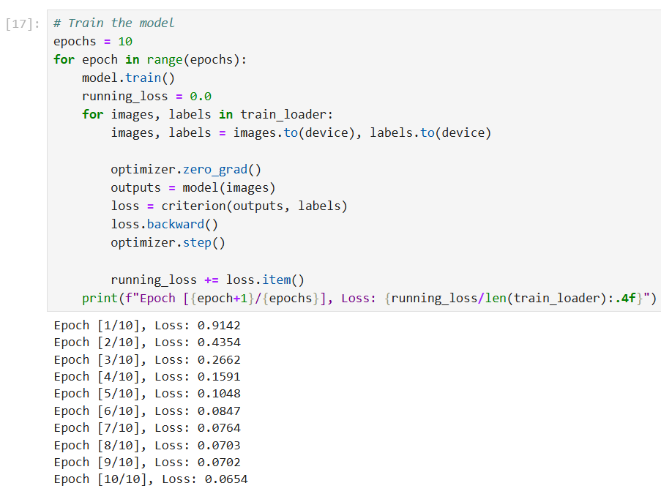

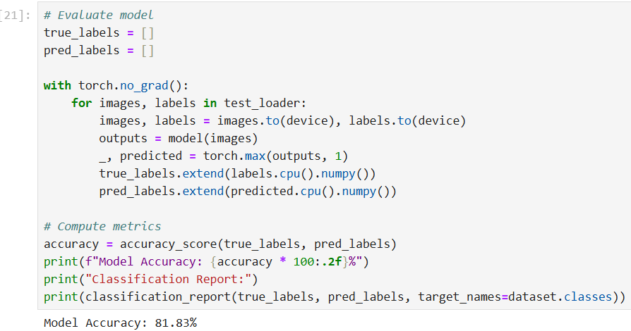Fig 6.6 Training Model

Fig 6.7 Evaluate Model

54

CHAPTER 7

RESULTS

The final System is going to predict which disease does a leaf possess with an accuracy of 81.83%.

7.1 Result of Leaf Images

**Loading Original Images** – For training purposes, a total of 1,600 leaf images are used. These images are categorized into two classes: *Healthy* and *Diseased*. Before processing, each image is converted from RGB (Red-Green-Blue) format to BGR (Blue-Green-Red) format.

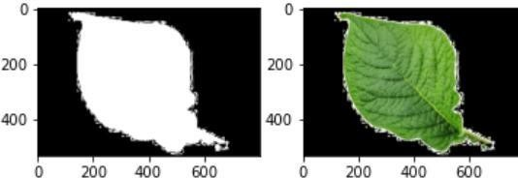

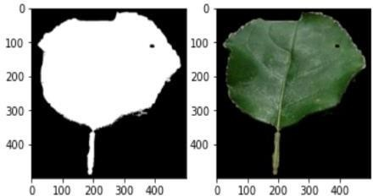Fig 7.1 Healthy Leaf

Fig 7.2 Diseased Leaf – Low

55

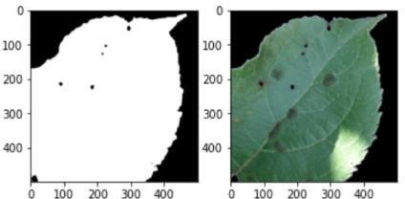

Fig 7.3 Diseased Leaf – Medium

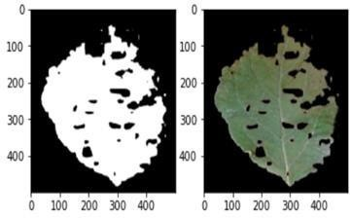

Fig 7.4 Diseased Leaf – High

7.2 Experiment

We experimented with several machine learning algorithm, but confined to build the CNN model mainly due to computational limitations. Table 6.1 shows the classification report of the CNN model for each disease class.

56

|  |  |  |  |  |
| --- | --- | --- | --- | --- |
| **Class** | **Precision** | **Recall** | **F1-Score** | **Support** |
| Apple___alternaria_leaf_spot | 0.96 | 0.8 | 0.87 | 56 |
| Apple___black_rot | 0.77 | 0.91 | 0.83 | 124 |
| Apple___brown_spot | 0.78 | 0.84 | 0.81 | 43 |
| Apple___gray_spot | 0.8 | 0.52 | 0.63 | 79 |
| Apple___healthy | 0.81 | 0.65 | 0.72 | 514 |
| Apple___rust | 0.8 | 0.62 | 0.7 | 248 |
| Apple___scab | 0.56 | 0.45 | 0.5 | 244 |
| Bell_pepper_bacterial_spot | 0.85 | 0.76 | 0.81 | 199 |
| Bell_pepper___healthy | 0.84 | 0.88 | 0.86 | 296 |
| Cassava_bacterial_blight | 0.25 | 0.17 | 0.2 | 217 |
| Cassava_brown_streak_disease | 0.32 | 0.28 | 0.3 | 438 |
| Cassava__green_mottle | 0.22 | 0.13 | 0.16 | 477 |
| Cassava___healthy | 0.27 | 0.26 | 0.27 | 516 |
| Cassava___mosaic_disease | 0.73 | 0.84 | 0.78 | 2632 |
| Cherry___healthy | 0.89 | 0.97 | 0.93 | 171 |
| Cherry___powdery_mildew | 0.98 | 0.9 | 0.94 | 210 |
| Coffee___healthy | 0.67 | 0.63 | 0.65 | 158 |
| Coffee___red_spider_mite | 0.0 | 0.0 | 0.0 | 33 |
| Coffee___rust | 0.44 | 0.53 | 0.48 | 120 |
| Corn___common_rust | 0.98 | 0.89 | 0.93 | 238 |
| Corn___gray_leaf_spot | 0.78 | 0.64 | 0.7 | 103 |
| Corn___healthy | 0.87 | 0.97 | 0.92 | 232 |
| Corn_northern_leaf_blight | 0.86 | 0.9 | 0.88 | 197 |
| Grape___Leaf_blight | 0.98 | 0.98 | 0.98 | 295 |
| Grape___black_measles | 0.93 | 0.82 | 0.87 | 534 |
| Grape___black_rot | 0.97 | 0.93 | 0.95 | 316 |
| Grape___healthy | 0.93 | 0.92 | 0.93 | 341 |
| Peach___bacterial_spot | 0.85 | 0.92 | 0.88 | 460 |
| Peach___healthy | 0.92 | 0.67 | 0.77 | 72 |
| Potato___bacterial_wilt | 0.63 | 0.59 | 0.61 | 114 |
| Potato___early_blight | 0.88 | 0.88 | 0.88 | 526 |
| Potato___healthy | 0.75 | 0.69 | 0.72 | 455 |
| Potato___late_blight | 0.76 | 0.8 | 0.78 | 417 |
| Potato___leafroll_virus | 0.98 | 0.76 | 0.86 | 105 |
| Potato___mosaic_virus | 0.75 | 0.84 | 0.79 | 133 |
| Potato___nematode | 0.27 | 0.21 | 0.24 | 14 |
| Potato___pests | 0.36 | 0.35 | 0.36 | 122 |
| Potato___phytophthora | 0.51 | 0.61 | 0.56 | 69 |
| Potato_spindle_tuber_viroid | 0.81 | 1.0 | 0.89 | 17 |

Table 7.1 Classification Report

57

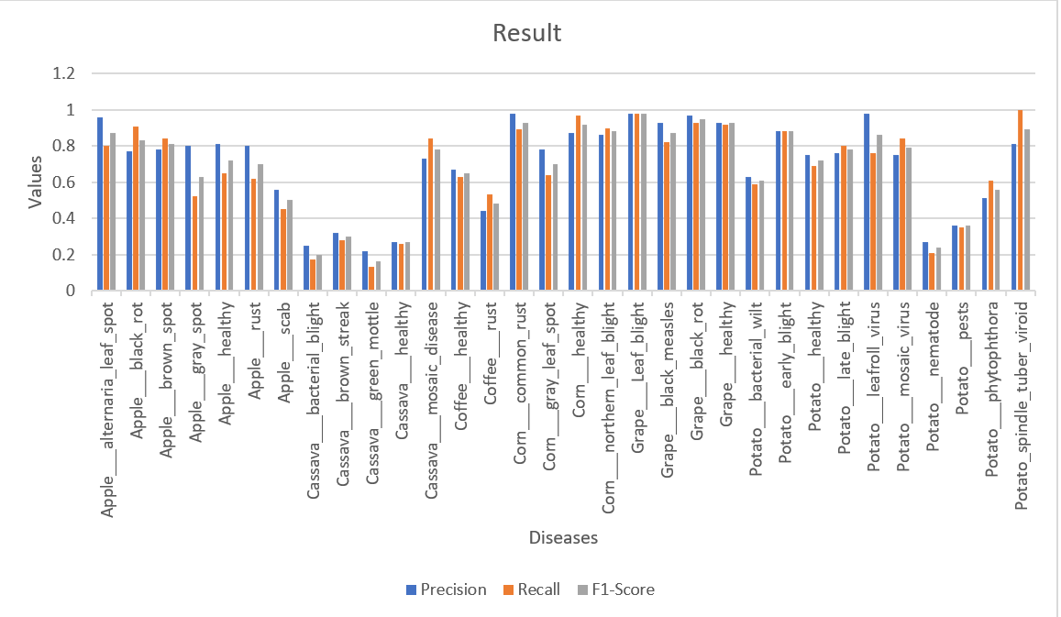

Fig 7.5 Visualization of classification

7.3 The Webpage

This how a webpage is going to look after deploying the model.

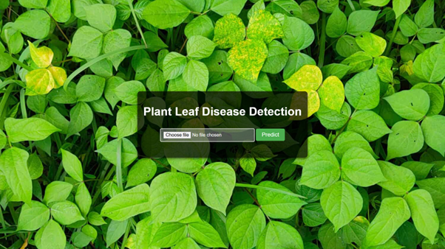

Fig 7.6 Webpage

58

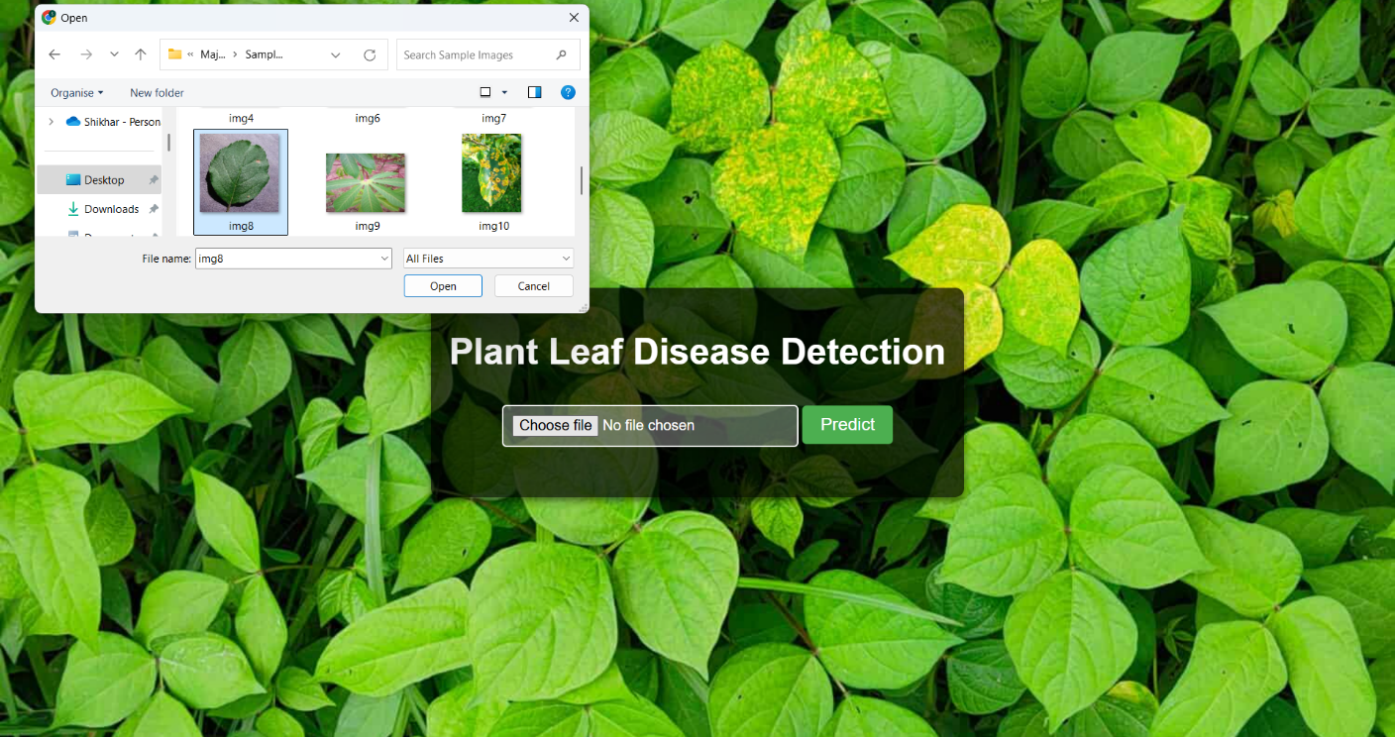

Fig 7.7 Choosing the image files

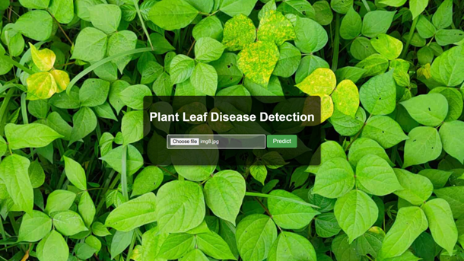

Fig 7.8 Click Predict

59

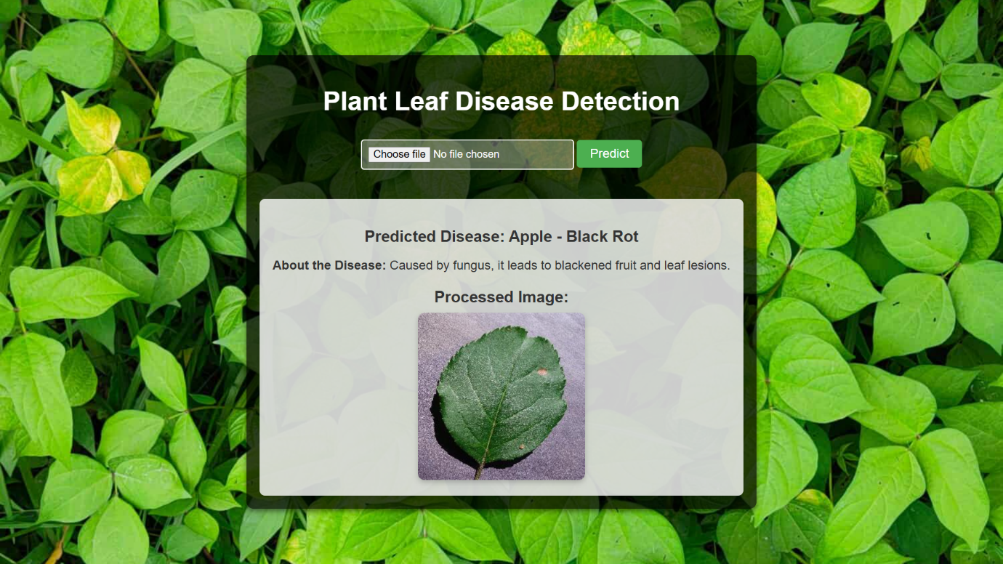

Fig 7.9 Output with leaf and its disease

60

**CONCLUSION**

Plant leaf disease detection using machine learning algorithms has shown significant potential in recent years. These algorithms are capable of accurately classifying plant leaves as either healthy or diseased, enabling early diagnosis and treatment. This early intervention helps prevent crop damage and minimizes yield loss.

In this project, we explored several machine learning algorithms including Logistic Regression, K-Nearest Neighbors (KNN), Naive Bayes, Support Vector Machines (SVMs), and Random Forests for the purpose of plant disease detection. We assessed their performance on different datasets by evaluating key metrics such as accuracy, precision, recall, and F1-score.

Additionally, we investigated the application of ResNet-50, a deep convolutional neural network, for plant disease detection using video datasets. ResNet-50 excels in extracting high-level features from images, making it particularly effective for this task. Our experiments demonstrated that ResNet-50 achieved high accuracy in identifying plant diseases from video frames.

Overall, our findings indicate that the Random Forest classifier performed the best among traditional machine learning models in terms of accuracy and generalization on image datasets, while ResNet-50 outperformed other models on video datasets. These results suggest that both algorithms can serve as reliable and efficient tools for automated plant disease detection.

With the advancement of technology, the demand for automated plant monitoring and management systems is growing. In agriculture, yield losses are often caused by diseases that are detected only in advanced stages. This late detection leads to significant losses in terms of productivity, time, and cost. The proposed system addresses this challenge by detecting diseases at an early stage—as soon as they appear on the leaf. This early detection helps reduce crop loss and lessens reliance on expert diagnosis. Furthermore, it can assist individuals with limited knowledge of plant diseases by providing clear disease identification. Achieving these objectives involves extracting relevant features associated with different plant diseases.

The emergence of plant pathogens poses a significant threat to global food security, ecosystems, and economies. Factors such as globalization, increased mobility, vectors, climate change, and pathogen evolution have accelerated the spread of invasive plant pathogens. To address agricultural losses, the development of automated approaches for plant disease detection and classification is urgently needed.

61

This review explores the use of machine learning (ML), deep learning (DL), and few-shot learning (FSL) for automated plant disease recognition. It highlights key methodologies, including acqui sition, preprocessing, segmentation, feature extraction, and classification. While many studies rely on RGB images, some have adopted hyperspectral imaging for plant leaves, which offers the advantage of detecting microscopic symptoms without requiring la beled datasets. These automated techniques have facilitated timely advancements in research. Additionally, the review examines molecular diagnostic tools and state-of the-art techniques for plant disease detection. The methods discussed are highly sensitive, specific, and capable of rapid detection.

62

**REFFERENCES**

1. FAO, IFAD, UNICEF, WFP, WHO, The State of Food Security and Nutrition in the World 2023. Geneva, Switzerland, Jul. 2023.
2. "State of Agriculture in India," accessed Aug. https://prsindia.org/files/policy/policy_analytical_reports 9, 2023.
3. C. Janiesch, P. Zschech, and K. Heinrich, "Machine learning and deep learning," Electron. Markets, vol. 31, no. 3, pp. 685–695, Apr. 2021, doi: 10.1007/s12525-021-00475-2.
4. K. Kc, Z. Yin, D. Li, and Z. Wu, "Impacts of background removal on convolutional neural networks for plant disease classification in-situ," Agriculture, vol. 11, no. 9, p. 827, Aug. 2021, doi: 10.3390/agriculture11090827.
5. J. Liu and X. Wang, "Plant diseases and pests detection based on deep learning: A review," Plant Methods, vol. 17, no. 1, pp. 1–18, Dec. 2021.
6. Y. Zhang, C. Song, D. Zhang, Deep learning-based object detection improvement for tomato disease, IEEE Access 8 (2020) 56607–56614, doi: 10.1109/ACCESS.2020.2982456.
7. G. Sambasivam, G.D. Opiyo, A predictive machine learning application in agriculture: Cassava disease detection and classification with imbalanced dataset using convolutional neural networks, Egypt. Inform. J. 22 (1) (2021) 27–34, doi: 10.1016/j.eij.2020.02.007.
8. I. Ahmed, P.K. Yadav, An automated system for early identification of diseases in plant through machine learning, in: Soft Computing: Theories and Applications: Proceedings of SoCTA 2021, Springer Nature Singapore, 2022, pp. 803–814.
9. M.H. Saleem, J. Potgieter, K.M. Arif, Plant disease classification: A comparative evaluation of convolutional neural networks and deep learning optimizers, Plants 9 (10) (2020) 1–17, doi: 10.3390/plants9101319.
10. Tirkey D, Singh KK, Tripathi S. Performance analysis of AI-based solutions for crop disease identification detection, and classification. Smart Agric Technol. 2023.

63

1. Jasim MA, Al-Tuwaijari JM. Plant leaf diseases detection and classification using image processing and deep learning techniques. Int Comput Sci Soft Eng Conf. 2020.
2. V. K. Shrivastava, M. K. Pradhan, S. Minz, and M. P. Thakur, “Rice plant disease classification using transfer learning of deep convolution neural network,” The International Archives of the Photogrammetry, Remote Sensing and Spatial Information Sciences, vol. XLII-3/W6, pp. 631–635, 2019.
3. K. Aderghal, A. Khvostikov, A. Krylov, J. Benois-Pineau, K. Afdel, and G. Catheline, “Classification of Alzheimer disease on imaging modalities with deep CNNs using cross modal transfer learning,” in 2018 IEEE 31st International Symposium on Computer-Based Medical Systems (CBMS), pp. 345–350, IEEE, Karlstad, Sweden, 2018.
4. A. Abdalla, H. Cen, L. Wan et al., “Fine-tuning convolutional neural network with transfer learning for semantic segmentation of ground-level oilseed rape images in a field with high weed pressure,” Computers and Electronics in Agriculture, vol. 167, Article ID 105091, 2019.
5. Kumar R, Chug A, Singh AP, Singh D. A systematic analysis of machine learning and deep learning based approaches for plant leaf disease classification: a Review. J Sensors. 2022
6. Tiwari V, Joshi RC, Dutta MK. Dense convolutional neural networks based multiclass plant disease detection and classification using leaf images. Ecol Inform. 2021.
7. Shoaib M, et al. An advanced deep learning models-based plant disease detection: a review of recent research. Front Plant Sci. 2023.
8. Ahmed I, Yadav PK. A systematic analysis of machine learning and deep learning based approaches for identifying and diagnosing plant diseases. Sustain Oper Comput. 2023;4:96–104.
9. Plant disease detection and classification techniques: a comparative study of the performances Wubetu Barud Demilie
10. Liu J, Wang X. Plant diseases and pests detection based on deep learning: a review. Plant Methods. 2021;17(1):1–18

64

1. Plant Leaf Disease Detection, Classification, and Diagnosis Using Computer Vision and Artificial Intelligence: A Review ANUJA BHARGAVA, AASHEESH SHUKLA, OM PRAKASH GOSWAMI, MOHAMMED H.ALSHARIF, PEERAPONG UTHANSAKUL, AND MONTHIPPA UTHANSAKUL
2. V. K. Vishnoi, K. Kumar, and B. Kumar, ‘‘Plant disease detection using computational intelligence and image processing,’’ J. Plant Diseases Protection, vol. 128, no. 1, pp. 19–53, Aug. 2020,
3. B. Liu, Y. Zhang, D. He, and Y. Li, ‘‘Identification of apple leaf diseases based on deep convolutional neural networks,’’ Symmetry, vol. 10, no. 1, p. 11, Dec. 2017.
4. R. Chen, H. Qi, Y. Liang, and M. Yang, ‘‘Identification of plant leaf diseases by deep learning based on channel attention and channel pruning,’’ Frontiers Plant Sci., vol. 13, Nov. 2022.
5. H. Nazki, S. Yoon, A. Fuentes, and D. S. Park, ‘‘Unsupervised image translation using adversarial networks for improved plant disease recognition,’’ Comput. Electron. Agricult., vol. 168, Jan. 2020, Art. no. 105117.
6. Y. Tian, G. Yang, Z. Wang, E. Li, and Z. Liang, ‘‘Detection of apple lesions in orchards based on deep learning methods of CycleGAN and YOLOV3 dense,’’ J. Sensors, vol. 2019, pp. 1–13, Apr. 2019.
7. Q. Wu, Y. Chen, and J. Meng, ‘‘DCGAN-based data augmentation for tomato leaf disease identification,’’ IEEE Access, vol. 8, pp. 98716–98728, 2020.
8. B. Liu, C. Tan, S. Li, J. He, and H. Wang, ‘‘A data augmentation method based on generative adversarial networks for grape leaf disease identification,’’ IEEE Access, vol. 8, pp. 102188–102198, 2020.
9. Z. Lin, S. Mu, A. Shi, C. Pang, and X. Sun, ‘‘A novel method of maize leaf disease image identification based on a multichannel convolutional neural network,’’ Trans. ASABE, vol. 61, no. 5, pp. 1461–1474, 2018.
10. J. G. Arnal Barbedo, "Plant disease identification from individual lesions and spots using deep learning," Biosyst. Eng., vol. 180, pp. 96–107, Apr. 2019.

65

1. S. M. Kiran and D. N. Chandrappa, ‘‘Plant disease identification using discrete wavelet transforms and SVM,’’ J. Univ. Shanghai Sci. Technol., vol. 23, no. 6, pp. 108–114, 2021. Available: https://jusst.org/wp-content/uploads/2021/06/Plant-Disease-Identification-Using-Discrete-Wavelet-Transforms-and-SVM-1.pdf
2. R. R. Patil and S. Kumar, ‘‘Rice-fusion: A multimodality data fusion framework for rice disease diagnosis,’’ IEEE Access, vol. 10, pp. 5207–5222, 2022.
3. D. Zhang, X. Zhou, J. Zhang, Y. Lan, C. Xu, and D. Liang, ‘‘Detection of rice sheath blight using an unmanned aerial system with high-resolution color and multispectral imaging,’’ PLoS ONE, vol. 13, no. 5, May 2018, Art. no. e0187470.
4. V. K. Shrivastava and M. K. Pradhan, ‘‘Rice plant disease classification using color features: A machine learning paradigm,’’ J. Plant Pathol., vol. 103, no. 1, pp. 17–26, Oct. 2020, doi: 10.1007/s42161-020-00683-3.
5. A. K. Rath and J. K. Meher, ‘‘Disease detection in infected plant leaf by computational method,’’ Arch. Phytopathol. Plant Protection, vol. 52, nos. 19–20, pp. 1348–1358, Dec. 2019.
6. L. Hallau, M. Neumann, B. Klatt, B. Kleinhenz, T. Klein, C. Kuhn,M. Röhrig, C. Bauckhage, K. Kersting, A. Mahlein, U. Steiner, andE. Oerke, ‘‘Automated identification of sugar beet diseases using smart- phones,’’ Plant Pathol., vol. 67, no. 2, pp. 399–410, Feb. 2018.
7. J. D. Pujari, R. Yakkundimath, and A. S. Byadgi, "SVM and ANN based classification of plant diseases using feature reduction technique," Int. J. Interact. Multimedia Artif. Intell., vol. 3, no. 7, p. 6, 2016.
8. R. D. L. Pires, D. N. Gonçalves, J. P. M. Oruě, W. E. S. Kanashiro,J. F. Rodrigues, B. B. Machado, and W. N. Gonçalves, ‘‘Local descriptors for soybean disease recognition,’’ Comput. Electron. Agricult., vol. 125, pp. 48–55, Jul. 2016.
9. S. Sladojevic, M. Arsenovic, A. Anderla, D. Culibrk, and D. Stefanovic, ‘‘Deep neural networks based recognition of plant diseases by leaf image classification,’’ Comput. Intell. Neurosci., vol. 2016, pp. 1–11, May 2016.
10. P. Jolly and S. Raman, ‘‘Analyzing surface defects in apples using Gabor features,’’ in Proc. 12th Int. Conf. Signal-Image Technol. Internet-Based Syst. (SITIS), Nov. 2016, pp. 178–185.

66

1. M. Sharif et al., "Detection and classification of citrus diseases in agriculture based on optimized weighted segmentation and feature selection," Computers and Electronics in Agriculture, vol. 150, pp. 220–234, Jul. 2018.
2. N. Sengar, M. K. Dutta, and C. M. Travieso, ‘‘Computer vision based technique for identification and quantification of powdery mildew dis- ease in cherry leaves,’’ Computing, vol. 100, no. 11, pp. 1189–1201, Nov. 2018.
3. S. M. Javidan, A. Banakar, K. A. Vakilian, and Y. Ampatzidis, ‘‘Diagnosis of grape leaf diseases using automatic K-means clustering and machine learning,’’ Smart Agricult. Technol., vol. 3, Feb. 2023, Art. no. 100081, doi: 10.1016/j.atech.2022.100081.
4. S. Zhang, Y. Zhu, Z. You, and X. Wu, "Fusion of superpixel, expectation maximization, and PHOG for recognizing cucumber diseases," Computers and Electronics in Agriculture, vol. 140, pp. 338–347, Aug. 2017.
5. G. Geetharamani and A. Pandian, ‘‘Identification of plant leaf diseases using a nine-layer deep convolutional neural network,’’ Comput. Electr. Eng., vol. 76, pp. 323–338, Jun. 2019
6. M. Mehdipour Ghazi, B. Yanikoglu, and E. Aptoula, ‘‘Plant identification using deep neural networks via optimization of transfer learning parameters,’’ Neurocomputing, vol. 235, pp. 228–235, Apr. 2017.
7. B. Liu, Y. Zhang, D. He, and Y. Li, ‘‘Identification of apple leaf diseases based on deep convolutional neural networks,’’ Symmetry, vol. 10, no. 1, p. 11, Dec. 2017.
8. R. Chen, H. Qi, Y. Liang, and M. Yang, ‘‘Identification of plant leaf dis- eases by deep learning based on channel attention and channel pruning,’’ Frontiers Plant Sci., vol. 13, Nov. 2022.
9. H. Nazki, S. Yoon, A. Fuentes, and D. S. Park, ‘‘Unsupervised image translation using adversarial networks for improved plant disease recog- nition,’’ Comput. Electron. Agricult., vol. 168, Jan. 2020, Art. no. 105117.
10. Y. Tian, G. Yang, Z. Wang, E. Li, and Z. Liang, ‘‘Detection of apple lesions in orchards based on deep learning methods of CycleGAN and YOLOV3-dense,’’ J. Sensors, vol. 2019, pp. 1–13, Apr. 2019.

67

1. Q. Wu, Y. Chen, and J. Meng, ‘‘DCGAN-based data augmenta- tion for tomato leaf disease identification,’’ IEEE Access, vol. 8, pp. 98716–98728, 2020.
2. B. Liu, C. Tan, S. Li, J. He, and H. Wang, ‘‘A data augmentation method based on generative adversarial networks for grape leaf disease identifi- cation,’’ IEEE Access, vol. 8, pp. 102188–102198, 2020.
3. Z. Lin, S. Mu, A. Shi, C. Pang, and X. Sun, ‘‘A novel method of maize leaf disease image identification based on a multichannel convolutional neural network,’’ Trans. ASABE, vol. 61, no. 5, pp. 1461–1474, 2018.
4. J. G. Arnal Barbedo, "Plant disease identification from individual lesions and spots using deep learning," Biosyst. Eng., vol. 180, pp. 96–107, Apr. 2019/
5. A. G. Howard, M. Zhu, B. Chen, D. Kalenichenko, W. Wang, T. Weyand,M. Andreetto, and H. Adam, ‘‘MobileNets: Efficient convolutional neural networks for mobile vision applications,’’ 2017, arXiv:1704.04861.
6. Lv, W., & Wang, X. (2020). Overview of hyperspectral image classification. Journal of Sensors, 2020, 1–13. https://doi.org/10.1155/2020/4817234

68